**Chapter -1**

**1. Introduction**

A student information system (SIS), student management system, school administration software or student administration system is a management information system for education establishments to manage student data and also data that is required to be projected to the student like announcements, schedules, results and information regarding workshops etc. Student Information Systems (often abbreviated as SIS systems) provide capabilities for registering, documenting grading transcripts and results of student test and other assessment scores, build student schedules, track student attendance, and manage many other student-related data needs in a school.

Coming to the theme of project, it will maintain student marks (mid marks, sem marks) and attendance. Based on the marks and attendance of each subject the grades will allocated independently for each subject at end of semester and **Sessional Grade Point Average (SGPA) calculated based on grades allocated to each subject in each sem. At final, the Cumulative Grade Point Average (CGPA) is calculated based on all the SGPA’s of all semesters. The calculated results were displayed in website.**

**1.1Purpose**

Security to the data of the student is very less and even it has failed in delivering information to students on time whenever they are in need. There are no alert systems in the current information system in the college. In spite of hiring a short message service server, the information required to be send to the student is not the reaching the ward due to various constraints like number of characters allowed in the message and also network availability on the other side. Moreover, when the results are displayed in current website all student marks are displayed to retrieved student. Here there is no encapsulation for marks that are displayed.

**1.2 About the project**

The proposedsystem overcomes the problem of being static. Results (grades and percentages), academic details of student, attendances etc. can only be accessed by only the concerned student by using his own login id and password. This provides security for the student data and also eases of accessing the data instead of retrieving the whole database for a single student data. Here, it just takes mid, sem marks and final attendance as input and automatically calculate the SGPA and CGPA of the student. Another important aspect in this project is containing a feedback form that can send feedback to concerned teacher through mail on behalf of college.

**Chapter -2**

1. **SYSTEM STUDY**
   1. **EXISTING SYSTEM**

In existing system information system that has been deployed follows following process

1. The user opens the college website
2. Checks for the required data about results, marks or attendance
3. Checks the details in his particular class or on the basis of semester
4. Now he would gain access to details of all the students regarding their marks, grades, attendance etc
5. Existing system does not maintain any secrecy in the data, i.e., it provides all the data to all the users.
6. What that is happening in the present system is, everything is being static.
7. The details regarding marks, grades, attendance etc are simply uploaded on the website server and the user can download all the data of all students, i.e., he is able to gain access over personal details of all students.
   1. **PROPOSED SYSTEM**

In Proposed System, We address the following features

1. This system administrator will provide individual login to each and every student and faculty
2. The registered student/ faculty would have login account.
3. After login, the student will be able to gain access to the data of only the particular his details regarding attendance, marks, grades etc.
4. Faculty will be able to post their daily attendance and also can access the details of individual students.
5. The system automatically maintains the data base of students and faculty every time the database administrator updates

So, that this system provides security to data of students and also eases the work of faculty to post the attendances directly on to the website

* 1. **FEASIBILITY STUDY**

**2.3.1Feasibility Assessment*:***

Feasibility study is a test of system proposal according to the workability, impact on the organization, ability to meet user needs and effective use of the available resources. The objective of feasibility study is not to solve the problem but to acquire a sense of its scope.

Once the problem is clearly understood the next step is to conduct the feasibility is a high level capsule version of the entire analysis and the design expense of how to solve a problem. The purpose of the feasibility study is not to solve a problem but to determine if the problem is worth solving. The system has been tested for the feasibility in terms of the following points

Three key combinations are involved in the feasibility analysis. They are:

**2.3.2 Economics Feasibility:**

Economic analysis is the most frequently used method for evaluating the effectiveness of a client system. More commonly known as cost/benefit analysis, the procedure is to determine the benefits and savings that are expecting from a client system and compare them with cost.

**2.3.3 Technical Feasibility:**

Technical feasibility centers on the existing system and to what extent it can support the proposed system. The benefits such as high accuracy, minimum response time and user friendliness of the proposed system over weights cost for designing and implementing the new system.

**2.3.4 Schedule Feasibility:**

The time schedule required for the development of the project is important, since more development time affects machine time and cost of delay in the development of other systems.

* 1. **SDLC METHODOLOGY**

The lifecycle of mobile development is largely no different than the SDLC for web or desktop applications. As with those, there are usually 5 major portions of the process:

1. **Inception** – All apps start with an idea. That idea is usually refined into a solid basis for an application.
2. **Design** – The design phase consists of defining the app’s User Experience (UX) such as what the general layout is, how it works, etc., as well as turning that UX into a proper User Interface (UI) design, usually with the help of a graphic designer.
3. **Development** – Usually the most resource intensive phase, this is the actual building of the application.
4. **Stabilization** – When development is far enough along, QA usually begins to test the application and bugs are fixed. Often times an application will go into a limited beta phase in which a wider user audience is given a chance to use it and provide feedback and inform changes.5.
5. **Deployment -** The team meets the Deployment Complete Milestone requirements and later completes post-project reviews with the customer and project team. And finally deploy the application in play store.

Often many of these pieces are overlapped, for example, it’s common for development to be going on while the UI is being finalized, and it may even inform the UI design. Additionally, an application may be going into a stabilization phase at the same that new features are being added to a new version.

* 1. **SYSTEM SPECIFICATIONS**

Before planning a replacing for a new system it is essential to have through knowledge about the existing system along with estimation of how lost computes can be used to make its operations more effective. System analysis is the process of collecting and interpreting facts, disposing problem and use the information about the existing system, which is also called as system study.

System analysis is about understanding situation but not solving the problem. System analysis is performed to determine whether a not it is feasible to design and information system laved on the policies and plans of an organization. To determine the user requirements and to eliminate the weakness of the present system a few general requirements are concerned.

**2.5.1 SOFTWARE REQUIREMENTS:**

* Operating System : Windows
* Technologies : Java, JSP
* Designing : CSS, Java Script (validation)
* Framework : Struts Framework 1.3
* Database : SQL Server 2012
* Application Server : Apache Tomcat 7.0
* IDE : Net Beans 8.0

**2.5.2 HARDWARE REQUIREMENTS:**

* Processor :Intel P4, I3, or higher
* RAM :512MB OR higher
* Hard Disk :40GB or higher
* LANCARD :USING

**2.5.3 FUNCTIONAL REQUIREMENTS:**

Functional requirements specify which outputs should be produced from the given inputs. They describe the relationship between the input and output of the system, for each functional requirement a detailed description of all data inputs and their source and the range of valid inputs must be specified.

All the operations to be performed on the input data to obtain the output should be specified.

* 1. **Inputs:** Inputs are nothing but student details. Here we upload the details of students regarding their marks, attendance, grades, cgpa etc. Input comes from the end of faculty in the form of attendance, input comes from the end of examination cell in the form of mid marks, semester marks, and input comes from the students in the form of feedback to teachers.
  2. **Outputs:**

**Reports:** We can generate many varieties of reports related to both students and faculty. In the terms of student, we’ll be able to student marks, cgpa, feedback for faculty for various subjects throughout all the semesters.

**External Interface Requirements:**

**User Interface:** Here user interface is developed using JSPs using which we can design and develop the pages which are attractive and dynamic. It is also very easy to navigate from one place to another place. We put lot of efforts to make the user interface attractive and process the data which is fed by the user.

**Software Interfaces:** This interface requirement should specify the inter face with other. Software which the system will use or which will use the system, this includes the interface with the operating system and other applications.

**Hardware Interfaces:** Hardware interface is very important to the documentation. If the software is execute on existing hardware or on the pre-determined hardware, all the characteristics of the hardware, including memory restrictions, should be specified. In addition, the current use and load characteristics of the hardware should be given.

**Performance Requirements:**

All the requirements relating to the performance characteristics of the system must be clearly specified. There are two types of performance requirements – static and dynamic.

Static Requirements are those that do not impose constraint on the execution characteristics of the system. These include requirements like the number of terminals to be supported, and number simultaneous users to be supported, number of files, and their sizes that the system has to process. These are also called capacity of the system. Dynamic requirements specify constraints on execution behaviour of the system. These typically include response time and throughput constraints on the system.

# The processing speed, respective resource consumption throughput and efficiency measure performance. For achieving good performance few requirements like reducing code, less use of controls, minimum involvement of repeated data etc., are to be followed. Each real-time system, software what provides required function but does not conform to performance of software requirements is acceptable. These requirements are used to test run time performance of software with the context of an integrated system.

**Deliverables:**

These are the outcomes from the System.

1. Implemented codes.

2. User manual.

3. Testing document.

4. Project Presentation (Expected)

**User characteristics:** In our project user is an administrator and a tester. Tester can easily feed the details of the bug clearly. And administrator can also control the system effectively.

**Assumptions and Dependencies:**

1. It is assumed that the java web server is Tomcat5.0, Tomcat is a commercial-quality web server solution based on the Java platform that supports the Servlets and JSP specifications.
2. All the details produced by the user are correct.
3. Assume that relational database is our Oracle 8i. Which is Object-Relational Database. That is used as backend storage for this project.
4. Other auxiliary systems like Java Database Connectivity (JDBC).

**Acceptance Criteria:**

Before accepting the system, the developer must demonstrate that the system works on the details of the user email-ids entered in the corresponding files. The developer will have to show through test cases that all conditions are satisfied.

**Chapter -3**

1. **SYSTEM DESIGN**

**3.1. Overview on technologies used and product**

**3.1.1. HTML:**

Hyper Text Markup Language, commonly referred to as HTML, is the standard markup language used to create web pages. It is written in the form of HTML elements consisting of tags enclosed in angle brackets (like <html>). HTML tags most commonly come in pairs like <h1> and </h1> although some tags represent empty elements and so are unpaired, for example <img>. The first tag in a pair is the start tag, and the second tag is the end tag (they are also called opening tags and closing tags).

Web browsers can read HTML files and compose them into visible or audible web pages. Browsers do not display the HTML tags and scripts, but use them to interpret the content of the page. HTML describes the structure of a website [semantically](http://en.wikipedia.org/wiki/Semantic) along with cues for presentation, making it a markup language, rather than a programming language.

To publish information for global distribution, one needs a universally understood language, a kind of publishing mother tongue that all computers may potentially understand. The publishing language used by the World Wide Web is HTML (Hyper text markup language).

Some common HTML tags are:

1. The ‘DOCTYPE’ declaration defines the document type to be HTML.
2. The text between <html> and </html> describes an HTML document.
3. The text between <head> and </head> provides information about the document.
4. The text between <title> and </title> provides a title for the document.
5. The text between <body> and </body> describes the visible page content.
6. The text between <h1> and </h1> describes a heading.
7. The text between <p> and </p> describes a paragraph.

**3.1.2. CSS:**

CSS stands for Cascading Style Sheets. CSS defines how HTML elements are to be displayed. Styles were added to HTML 4.0 to solve a problem. CSS saves a lot of work. External Style Sheets are stored in CSS files. HTML was NEVER intended to contain tags for formatting a document. HTML was intended to define the content of a document, like:

<h1>This is a heading</h1>

<p>This is a paragraph. </p>

When tags like <font>, and color attributes were added to the HTML 3.2 specification, it started a nightmare for web developers. Development of large web sites, where fonts and color information were added to every single page, became a long and expensive process.

To solve this problem, the World Wide Web Consortium created CSS.

**CSS Saves a Lot of Work:**

The style definitions are normally saved in external .css files.

With an external style sheet file, you can change the look of an entire Web site by changing just one file!

**CSS Syntax:**

A CSS rule set consists of a selector and a declaration block:

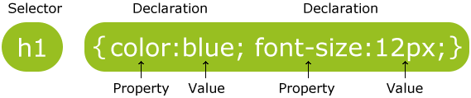

**Fig 3.1. CSS Syntax**

* The selector points to the HTML element you want to style.
* The declaration block contains one or more declarations separated by semicolons.
* Each declaration includes a property name and a value, separated by a colon.

**Types of CSS:**

The CSS is generally divided into 3 types for the convenience, they are as follows:

1. Inline CSS.
2. Internal CSS.
3. External CSS.

**JAVA SCRIPT:**

JavaScript is one of the most important languages used in web development. It has many uses ranging from checking the values submitted by forms to controlling interactive widgets, such as tabbed panels, accordions, and fly out menus. It’s also used to create photo galleries, and to fetch new information from the web server to refresh content without the need to reload the page-a combination of technologies commonly known as Ajax.

Along with HTML and CSS, knowledge of JavaScript is a key skill that anyone involved in building websites should acquire. Yet many web designers never do. JavaScript has a reputation for being too difficult; and graphic designers frequently insist that their role is to design, not to program. Even if you never do any JavaScript programming yourself, it’s important to understand how the structure of your web pages affects the job of the JavaScript programmer. What’s more, JavaScript has become easier to use thanks to code libraries such as jQuery.

**What is JavaScript what is it for?**

In spite of similarity of names, JavaScript is not Java. The languages are not related. Java is frequently used to program games, mobile phones, and other devices, such as the Amazon Kindle. Although java can be used in websites, it’s rarely used that way.

JavaScript, on the other hand, is a lightweight, yet powerful language that normally runs inside a web browser. Its role is to provide access to different elements of the page so that they can be removed or updated. It can also create new elements, change the style of existing elements, or extract information from them. For example, it can read the values entered into a form, perform a calculation, and display the result. It can also send a request to the web server for more information, and update part of the page without needing to reload it.

JavaScript performs these tasks by accessing the Document Object Model (DOM).The DOM is a structure similar to a family tree. If the HTML markup of your page is invalid or too complex, the JavaScript code can’t navigate the family tree. Similarly, if you break simple rules, such as not using the same ID more than once in any page, JavaScript becomes confused and simply gives up.

**The importance of events:**

JavaScript is an event-driven language. Some events are triggered automatically. For example the **load** event is triggered when the page finishes loading in the browser, and it’s frequently used to initialize fly out menus and other widgets. Other events are triggered by the user, the most common being the **click** event when the user clicks the main mouse button, or taps on a touch-sensitive screen. Other common events include **mouseover** and **mouseout**, when the user hovers over an element, and submit, when a form is submitted.

Events are being triggered all the time. An event is triggered every time you move the mouse, scroll the page, or press a key. It would be chaos if the browser had to respond to every event. Instead, you as the developer create functions to handle specific events, and you associate them with the page elements that you want to respond to the event. This is known as binding an event handler.

Event handler functions sit and wait-or listen-for the event. When the appropriate event is triggered, the event handler jumps into action and performs its designated task, such as opening or closing a fly out menu, submitting a form, or changing the style of an element.

**JSP:**

JSP is what is known as a Server-Side-Scripting Language-which means that it is interpreted on the web server before the webpage is sent to a web browser to be displayed. The acronym of JSP is Java Server Page and it is a technology based on java language and enables the development of dynamic websites. The diagram outlines the process how JSP interacts with a MYSQL database.

**Simplification of Process:**

The JSP language has a simple development and maintenance process. A JSP file that has the extension .jsp is converted into a servlet .java which is dynamically compiled, loaded and executed. Only when there is a change in a JSP file, the Conversion, compilation, and loading process is then performed.

**Elements of JSP:**

A .JSP file can contain JSP elements fixed template data or any combinations of the two. The Jsp elements are instructions to the Jsp container about what code to generate and how should it operates. These elements have specific start and end tags that identified them to the Jsp compiler. Template data is everything else that is not recognized by the Jsp container.

Template data usually HTML data is passed through unmodified. So the HTML i.e., ultimately generated contains the template data exactly as it was coded in the .jip file.

There are three types of Jsp elements:-

1. Directives.
2. Scripting elements.
3. Actions.

**I. Directives:**

Directives are instructions to the Jsp container that describes what code should be generated.

They have the general form –

**< % @ directive name [attribute = “value” attribute= “value” …% >**

Three standard directives available in all compilation Jsp environments:

1. Page,
2. Include and,
3. Taglib.

**Comments:**

The Jsp specifications provide two means of including comments in a Jsp page. One for hidden comments only visible in the Jsp file itself and one for comments included in the HTML or XML output generated by the page.

The former type has the syntax -

**<% -- This is a hidden Jsp comment - - % >**

And later looks like this –

**< ! - - This is included in the generated HTML - - >**

**My SQL:**

**MySQL** is the world's second most widely used relational database management system (RDBMS) and most widely used open-source RDBMS. It is an Open source (GPL) standard Query Language (SQL) database that is fast, reliable, easy to use, and suitable for applications of any size.SQL is the ANSI standard database query language used by most databases (though all have their nonstandard extensions) . SQL is a database language that is used to retrieve, insert, delete and update stored data .This is achieved by constructing conditional statements that confirm to a specific syntax (i.e. the strict order required of elements for a statement to work).

**Introduction To Servers:**

Apache Tomcat is an open-source web server and servelet container developed by the Apache software foundation (ASF). Tomcat implements several javaEE specifications including java servelet, JAVA SERVER PAGES (JSP), java EL and web socket, and provides a pure java HTTP web server environment for java code to run in. It has also added user- as well as system-based web applications enhancement to add support for deployment across the variety of environments. It also tries to manage sessions as well as applications across the network.

Tomcat is building additional components. A number of additional components may be used with Apache Tomcat. These components may be built by users should they need them or they can be downloaded from one of the mirrors

**3.1.1 Input Design:**

Input design is the process of converting user-originated information to computer-based format. The goal of designing input data is to make data entry as easier and error free as possible. An input format should be easy to understand.

In this product inputs are nothing but forms fed with data. Using the JSP pages provides high-level graphical user interface.

**3.1.2 OBJECTIVES:**

* Main objective of Student information system is to provide dynamic user interface to the end user rather than putting static
* Primary objective to avoid unnecessary data retrieval and this is achieved through this project
* Reduces the user interaction work.
* The wastage of time is reduced.
* It also helps in retrieval of relevant data by the users like both students and faculty .
* More flexible it means user (administrator) can add his own number of filters if he interested easily.

**3.1.3 Output Design:**

Output reflects image of the organization. The output design involves designing forms layout, making lists, making well designed reports etc., and reports are main outputs of the proposed system. Here the outputs are : variety of reports on bugs like project wise bug report, module wise bug report, priority wise bug reports and total bugs occurred during some period. Also we can know the bugs which have solved. All these reports are generated dynamically and we produce these using html table tags.

**3.1.4 Database Design:**

Databases and database management systems and explores how to use relationships in a pool of data when developing methods for data storage and retrieval. Databases allow data to be shared among different applications.

We used oracle (object – relational Database) in our system. We have a small set of tables which are divided into number of tables according to normalization concept. Designing the database well effect on reports. If we designed it well we can generate any kind of complex report easily. And the same time we maintain data integrity and consistency.

Databases and database management systems explores how to use relationships in a pool of data when developing methods for data storage and retrieval. Databases allow data to e shared among different applications.

**3.2 MODULARIZATION:**

In the Project titled “Student information system”, the modules are

**1.**Admin module

**2.**Department (faculty) module

**3.**Examination cell module

**4.**Student module

**5.** Feedback module

**Admin login module:** It helps in keeping track of whole system. Administrator will be solely responsible for the database maintenance, mailing of feed backs to respective head of the departments and also he will be responsible for the updating of attendance every day.

.**Faculty login module**: Initially the faculty of the college will be added into the database by the administrator. Later upon addition into the college data base, faculty need to register to through the website in their concerned department and later they will receive the password to their login through mail and upon logging into their account they will be able to post daily attendances, view student semester wise marks, student details.

**Examination cell login module:** examination cell department people can log into to their account for any concerned department and will be able to view the attendance of students and also can update student mid wise marks and also can post student’s semester wise marks.

**Student login module:**all the students will be initially registered by the administrator and individual login id’s and passwords will be given to them so as it log in to their account to view their details regarding their attendance, mid wise marks, semester wise marks and also they will be able to print the details that they are in need.

**Feedback login module:** In this all students will be able to individually submit feedback reports to each every teacher dealing with each and every subject. Upon receipt of the feedbacks, administrator will forward the feedbacks to concerned department heads.

**3.3. UML DIAGRAMS**

* The unified modeling language allows the software engineer to express an analysis model using the modeling notation that is governed by a set of syntactic semantic and pragmatic rules.
* A UML system is represented using five different views that describe the system from distinctly different perspective. Each view is defined by a set of diagram, which is as follows.

**User Model View**

This view represents the system from the users perspective. The analysis representation describes a usage scenario from the end-users perspective.

**Structural model view**

In this model the data and functionality are arrived from inside the system. This model view models the static structures.

**Behavioral Model View**

It represents the dynamic of behavioral as parts of the system, depicting the interactions of collection between various structural elements described in the user model and structural model view.

**Implementation Model View**

In this the structural and behavioral as parts of the system are represented as they are to be built.

**Environmental Model View**

In this the structural and behavioral aspects of the environment in which the system is to be implemented are represented.

UML is specifically constructed through two different domains they are

* UML Analysis modeling, which focuses on the user model and structural model views of the system.
* UML design modeling, which focuses on the behavioral modeling, implementation modeling and environmental model views.

Use case Diagrams represent the functionality of the system from a user’s point of view. Use cases are used during requirements elicitation and analysis to represent the functionality of the system. Use cases focus on the behavior of the system from external point of view.

Actors are external entities that interact with the system. Examples of actors include users like administrator, bank customer …etc., or another system like central database.

**Use case diagram**

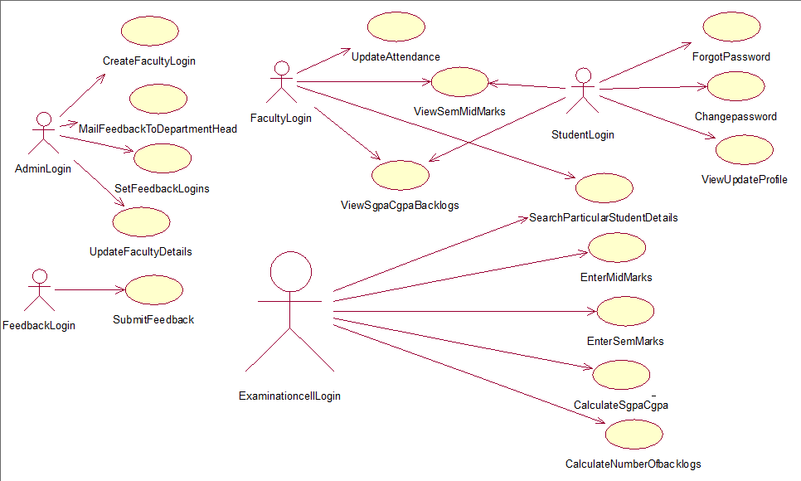

**Fig 3.3.1 : Usecase diagram**

**Class diagram**

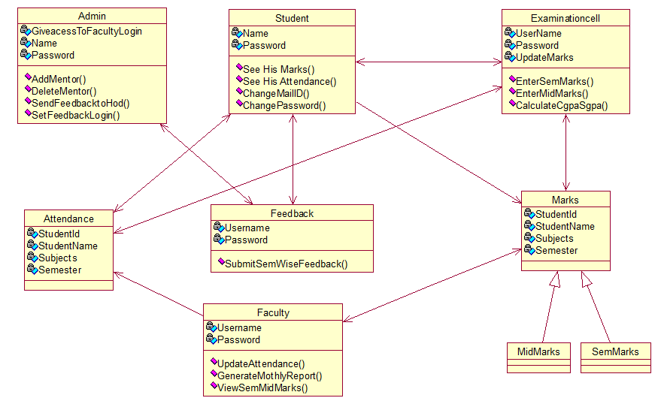

**Fig 3.3.2: Class diagram**

**Sequence diagram**

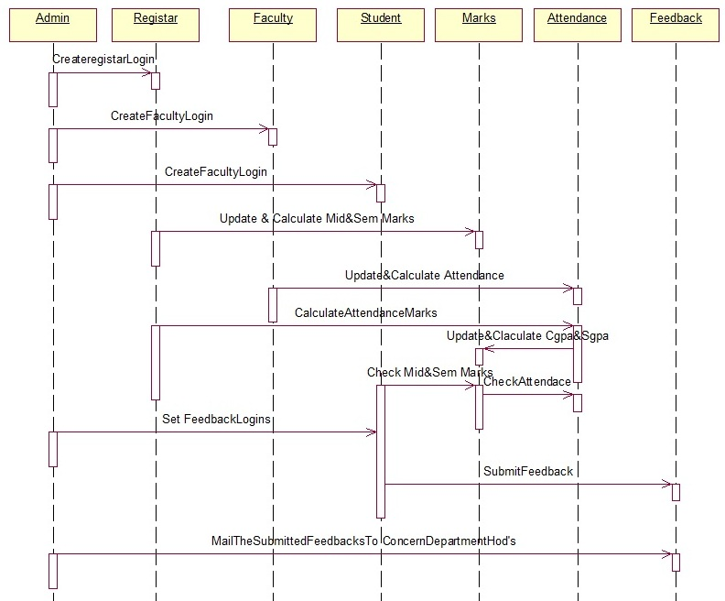

**Fig 3.3.3: sequence diagram**

**Collaboration diagram**

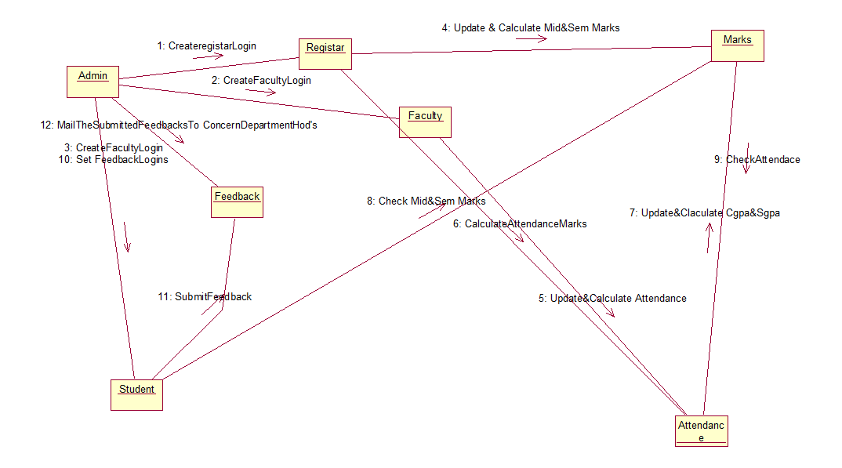

**Fig 3.3.4. Collaboration diagram**

**Activity diagram**

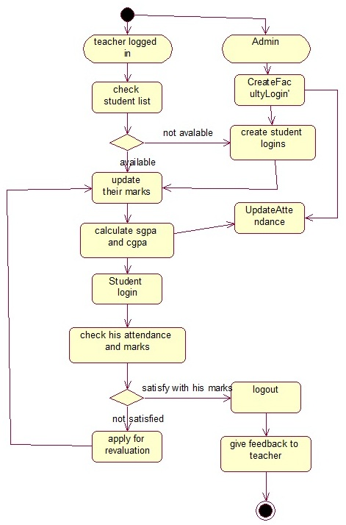

**Fig 3.3.5 : Activity diagram**

**State chart diagram**

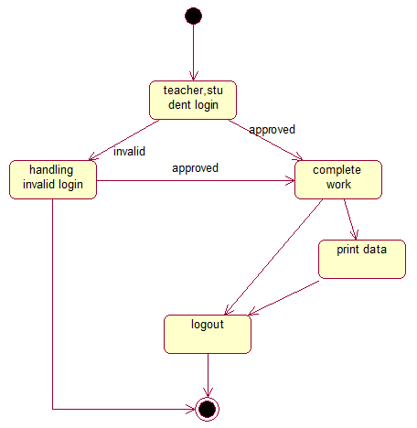

**Fig 3.3.6: State chart diagram**

**Component diagram**

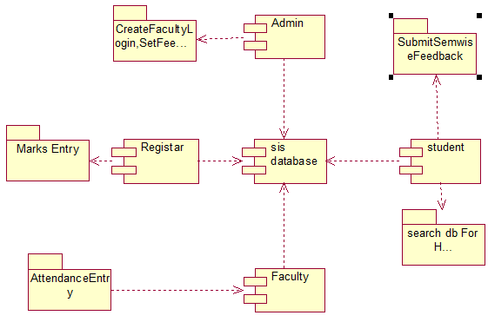

**Fig 3.3.7: Component diagram**

**Deployment diagram**

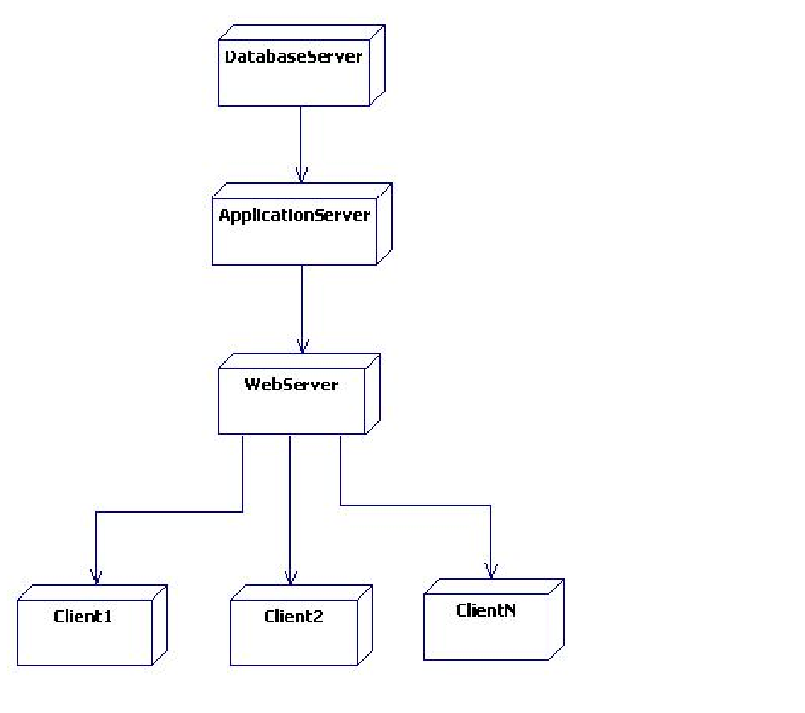

**Fig 3.3.8: Deployment diagram**

* 1. **NORMALIZATION**

The entity Relationship Diagram (ERD) depicts the relationship between the data objects. The ERD is the notation that is used to conduct the date modelling activity the attributes of each data object noted is the ERD can be described resign a data object descriptions. The set of primary components that are identified by the ERD are Data object, Relationships, Attributes, Various types of indicators.

Note : We can find the er diagram of the project in the next page.

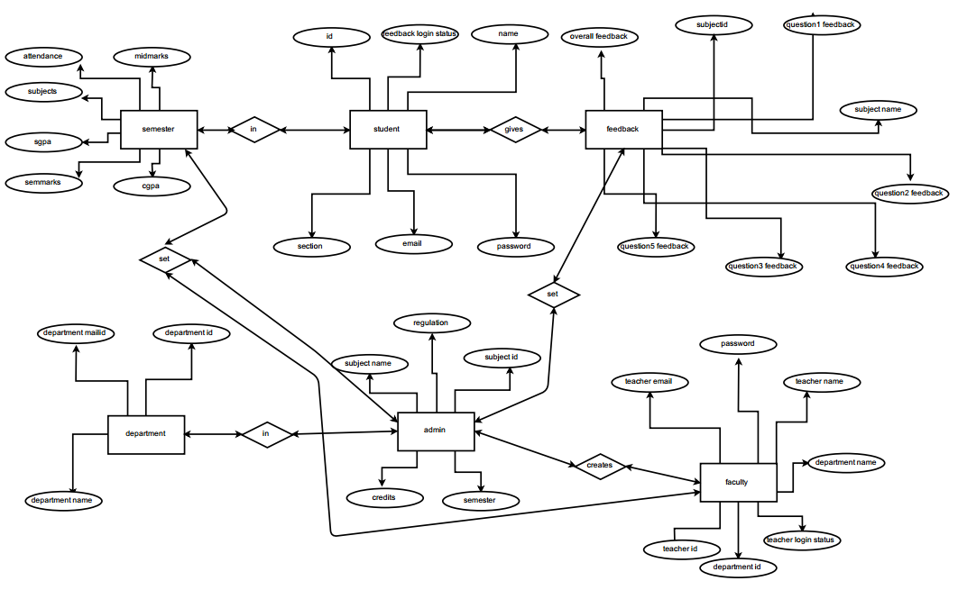

**Fig 3.3.8: E-R diagram**

* 1. **Data base tables**

**Credits table**

1. CREATE TABLE [dbo].[adminlog](
2. [reg] [nchar](10) NOT NULL,
3. [subname] [varchar](50) NOT NULL,
4. [credits] [real] NOT NULL,
5. [sem] [nchar](10) NOT NULL
6. ) ON [PRIMARY]

**Department login:**

1. CREATE TABLE [dbo].[dlogin](
2. [uname] [varchar](50) NOT NULL,
3. [pwd] [varchar](50) NOT NULL,
4. CONSTRAINT [PK_login] PRIMARY KEY CLUSTERED
5. (
6. [uname] ASC
7. )WITH (PAD_INDEX = OFF, STATISTICS_NORECOMPUTE = OFF, IGNORE_DUP_KEY = OFF, ALLOW_ROW_LOCKS = ON, ALLOW_PAGE_LOCKS = ON) ON [PRIMARY]
8. ) ON [PRIMARY]

**Student Login:**

1. CREATE TABLE [dbo].[stdlogin](
2. [sid] [nvarchar](255) NOT NULL,
3. [sname] [nvarchar](255) NULL,
4. [email] [nvarchar](255) NOT NULL,
5. [pswd] [nvarchar](255) NOT NULL
6. ) ON [PRIMARY]

**Feedback Department head mail id list Table:**

1. CREATE TABLE [dbo].[feed](
2. [id] [smallint] NOT NULL,
3. [dname] [nvarchar](255) NOT NULL,
4. [mailid] [nvarchar](255) NOT NULL
5. ) ON [PRIMARY]

**Feedback Teachers List Table:**

1. CREATE TABLE [dbo].[feedt](
2. [id] [smallint] NOT NULL,
3. [dname] [nvarchar](255) NULL,
4. [tid] [smallint] NOT NULL,
5. [tname] [nvarchar](255) NULL
6. ) ON [PRIMARY]
7. **Feddback Teacher Subject List Table:**
8. CREATE TABLE [dbo].[feedsub](
9. [tid] [smallint] NOT NULL,
10. [sname] [nchar](10) NOT NULL
11. ) ON [PRIMARY]
12. **Final Feedback Table:**
13. CREATE TABLE [dbo].[feedback](
14. [fid] [int] IDENTITY(1,1) NOT NULL,
15. [dname] [varchar](50) NOT NULL,
16. [tname] [varchar](50) NOT NULL,
17. [subname] [varchar](50) NOT NULL,
18. [mail] [varchar](50) NOT NULL,
19. [fpost] [varchar](max) NOT NULL,
20. CONSTRAINT [PK_feedback] PRIMARY KEY CLUSTERED
21. (
22. [fid] ASC
23. )WITH (PAD_INDEX = OFF, STATISTICS_NORECOMPUTE = OFF, IGNORE_DUP_KEY = OFF, ALLOW_ROW_LOCKS = ON, ALLOW_PAGE_LOCKS = ON) ON [PRIMARY]
24. ) ON [PRIMARY] TEXTIMAGE_ON [PRIMARY]
25. **First Semester Table:**
26. CREATE TABLE [dbo].[first](
27. [sid] [nvarchar](255) NOT NULL, [sname] [nvarchar](255) NULL,
28. [section] [nvarchar](255) NULL,
29. [dcn] [nvarchar](255) NULL, [dcd] [nvarchar](255) NULL,
30. [dwt] [nvarchar](255) NULL, [dli] [nvarchar](255) NULL, [dcg] [nvarchar](255) NULL,
31. [dpe] [nvarchar](255) NULL, [dwtlab] [nvarchar](255) NULL,
32. [dlilab] [nvarchar](255) NULL, [nwdcn] [nvarchar](255) NULL,
33. [nadcn] [nvarchar](255) NULL,[nwdcd] [nvarchar](255) NULL,
34. [nadcd] [nvarchar](255) NULL,[nwdwt] [nvarchar](255) NULL,
35. [nadwt] [nvarchar](255) NULL,[nwdli] [nvarchar](255) NULL,
36. [nadli] [nvarchar](255) NULL,[nwdcg] [nvarchar](255) NULL,
37. [nadcg] [nvarchar](255) NULL,[nwdpe] [nvarchar](255) NULL,
38. [nadpe] [nvarchar](255) NULL,[nwdwtlab] [nvarchar](255) NULL,
39. [nadwtlab] [nvarchar](255) NULL,[nwdlilB] [nvarchar](255) NULL,
40. [nadlilab] [nvarchar](255) NULL,[Acn] [nvarchar](255) NULL,
41. [Acd] [nvarchar](255) NULL,[Awt] [nvarchar](255) NULL,
42. [Ali] [nvarchar](255) NULL,[Acg] [nvarchar](255) NULL,
43. [Ape] [nvarchar](255) NULL,[Awtlab] [nvarchar](255) NULL,
44. [Alilab] [nvarchar](255) NULL,[Af] [nvarchar](255) NULL,
45. [Mcn] [nvarchar](255) NULL,[Mcd] [nvarchar](255) NULL,
46. [Mwt] [nvarchar](255) NULL,[Mli] [nvarchar](255) NULL,
47. [Mcg] [nvarchar](255) NULL,[Mpe] [nvarchar](255) NULL,
48. [Mwtlab] [nvarchar](255) NULL,[Mlilab] [nvarchar](255) NULL,
49. [Scn] [nvarchar](255) NULL,[Scd] [nvarchar](255) NULL,
50. [Swt] [nvarchar](255) NULL,[Sli] [nvarchar](255) NULL,
51. [Scg] [nvarchar](255) NULL,[Spe] [nvarchar](255) NULL,
52. [Swtlab] [nvarchar](255) NULL,[Slilab] [nvarchar](255) NULL,
53. [Gcn] [nvarchar](255) NULL,[Gcd] [nvarchar](255) NULL,
54. [Gwt] [nvarchar](255) NULL,[Gli] [nvarchar](255) NULL,
55. [Gcg] [nvarchar](255) NULL,[Gpe] [nvarchar](255) NULL,
56. [Gwtlab] [nvarchar](255) NULL,[Glilab] [nvarchar](255) NULL,
57. [Nbl] [nvarchar](255) NULL,[Tou] [nvarchar](255) NULL,
58. [Lou] [nvarchar](255) NULL,[Sgpa] [nvarchar](255) NULL,
59. ) ON [PRIMARY]

**Chapter - 4**

1. **Implementation**

**4.1 CODING:**

After Designing the System, it is very comfortable to implement the design in terms of Programming Language. That means, now we should develop the entire system technically using various technologies that are mentioned in the Requirements document.

For the development of the “Student information system”, we are using technologies like Servlets/JSPs for designing front end and Oracle for Database Storage. JDBC technology is also used for the connection of Application to the Database.

**Admin module**:

**Home.jsp:**

<%@page contentType="text/html" pageEncoding="UTF-8"%>

<%@ taglib uri="http://struts.apache.org/tags-logic" prefix="logic" %>

<%@ taglib uri="http://struts.apache.org/tags-bean" prefix="bean" %>

<%@ taglib uri="http://struts.apache.org/tags-html" prefix="html" %>

<% String contextPath = request.getContextPath();%>

<!DOCTYPE html>

<html>

<head>

<meta http-equiv="Content-Type" content="text/html; charset=UTF-8">

<link rel="stylesheet" href="<%=contextPath%>/Start/admin/Css/style.css" type="text/css" media="screen" />

<link rel="stylesheet" href="<%=contextPath%>/Start/Css/prettyPhoto.css" type="text/css" media="screen" />

<script SRC="<%=contextPath%>/Start/Css/scripts.js" type="text/javascript"></script>

<title>JSP Page</title>

<script>

window.history.forward();

</script>

</head>

<body>

<%

if (session.getAttribute("username") == null) {

response.sendRedirect("./Start/admin/logout.jsp");

} else if (session.getAttribute("alog") == null) {

response.sendRedirect("./Start/admin/logout.jsp");

} %><% int k = 1;%>

<div id="wrap">

<h1><img src="<%=contextPath%>/Start/Images/Home/1.jpg" width="35"/>&nbsp<a target="_blank" href="http://lbrce.ac.in/" target="_blank">Lakireddy Balireddy College Of Engineering</a></h1>

<h3 class="slogan"><b>Student Information System</b></h3>

<nav>

<div id="menubar">

<ul id="nav">

<li class="current"><a href="ahome.pvk">Home</a></li>

<li ><a href="addmentor.pvk">Add New Mentor</a></li>

<li><a href="deletementor.pvk">Delete Mentor</a></li>

<li><a href="feedbacka.pvk">Feedback</a></li>

<li><a href="./Start/admin/logout.jsp">Logout</a></li>

</ul>

</div><!--close menubar-->

</nav>

</div>

<div id="content">

<div id="scrollContent">

<html:form action="ahome" method="post">

<logic:notEmpty name="list">

<center> <table align="center" border="1" >

<tr align="center" bgcolor="green" style="color:white;">

<th>Department ID</th>

<th>Department Name</th>

<th>Teacher Id</th>

<th>Teacher Name</th>

<th>Teacher EmailId</th>

<th>Teacher Login Status</th>

</tr>

<logic:iterate name="list" id="user" >

<tr>

<td ><input autocomplete="off" size="3" type="text" name="did<%=k%>" value="${user.did}" /></td>

<td ><input autocomplete="off" size="3" type="text" name="dname<%=k%>" value="${user.dname}" /></td>

<td ><input autocomplete="off" size="3" type="text" name="tid<%=k%>" value="${user.tid}" readonly/></td>

<td ><input autocomplete="off" size="3" type="text" name="tname<%=k%>" value="${user.tname}" /></td>

<td ><input autocomplete="off" type="text" name="temail<%=k%>" value="${user.temail}" /></td>

<td ><input autocomplete="off" type="text" name="log<%=k%>" value="${user.log}" /></td>

<%k++;%>

</tr>

</logic:iterate>

</table></center>

<input type="hidden" name="sdae" value="<%=k%>"/>

</logic:notEmpty>

<br> <center><input type="submit" value="Update Details" /></center>

</html:form>

</div>

</div>

</body>

</html>

**Addmentor.jsp:**

<!DOCTYPE html>

<html>

<head>

<meta http-equiv="Content-Type" content="text/html; charset=UTF-8">

<link rel="stylesheet" href="<%=contextPath%>/Start/admin/Css/style.css" type="text/css" media="screen" />

<link rel="stylesheet" href="<%=contextPath%>/Start/Css/prettyPhoto.css" type="text/css" media="screen" />

<script SRC="<%=contextPath%>/Start/Css/scripts.js" type="text/javascript"></script>

<title>JSP Page</title>

<script>

window.history.forward();

</script>

</head>

<body>

<%

if (session.getAttribute("username") == null) {

response.sendRedirect("./Start/admin/logout.jsp");

} else if (session.getAttribute("alog") == null) {

response.sendRedirect("./Start/admin/logout.jsp");

}

%><% int k = 1;%>

<div id="wrap">

<h1><img src="<%=contextPath%>/Start/Images/Home/1.jpg" width="35"/>&nbsp<a target="_blank" href="http://lbrce.ac.in/" target="_blank">Lakireddy Balireddy College Of Engineering</a></h1>

<h3 class="slogan"><b>Student Information System</b></h3>

<nav>

<div id="menubar">

<ul id="nav">

<li ><a href="ahome.pvk">Home</a></li>

<li class="current"><a href="addmentor.pvk">Add New Mentor</a></li>

<li><a href="deletementor.pvk">Delete Mentor</a></li>

<li><a href="feedbacka.pvk">Feedback</a></li>

<li><a href="./Start/admin/logout.jsp">Logout</a></li>

</ul>

</div><!--close menubar-->

</nav>

</div>

<div id="content">

<div id="scrollContent">

<html:form action="addmenact.pvk" method="post">

<center><font color="red" size="4"><%

Object status = request.getAttribute("status");

if (status == null) {

} else {

out.print(request.getAttribute("status"));

}

%></font></center>

<center> <table border="1" >

<tr align="center" bgcolor="green" style="color:white;">

<th>Department ID</th>

<td ><input autocomplete="off" size="3" type="number" name="did" required /></td>

</tr>

<tr>

<th>Department Name</th>

<td ><input autocomplete="off" size="3" type="text" name="dname" required /></td>

</tr>

<tr>

<th>Teacher Id</th> <td ><input autocomplete="off" size="3" type="number" name="tid" required/></td>

</tr> <tr>

<th>Teacher Name</th> <td ><input autocomplete="off" size="3" type="text" name="tname" required/></td>

</tr> <tr> <th>Teacher EmailId</th> <td ><input autocomplete="off" type="text" name="temail" required /></td></tr>

</table></center>

<br> <center><input type="submit" value="Add Mentor" /></center><br><br><br><br><br>

</html:form>

</div>

</div>

</body>

</html>

**Deletementor.jsp:**

<!DOCTYPE html>

<html>

<head>

<meta http-equiv="Content-Type" content="text/html; charset=UTF-8">

<link rel="stylesheet" href="<%=contextPath%>/Start/admin/Css/style.css" type="text/css" media="screen" />

<link rel="stylesheet" href="<%=contextPath%>/Start/Css/prettyPhoto.css" type="text/css" media="screen" />

<script SRC="<%=contextPath%>/Start/Css/scripts.js" type="text/javascript"></script>

<title>JSP Page</title>

<script>

window.history.forward();

</script>

</head>

<body>

<%

if (session.getAttribute("username") == null) {

response.sendRedirect("./Start/admin/logout.jsp");

} else if (session.getAttribute("alog") == null) {

response.sendRedirect("./Start/admin/logout.jsp");

}

%><% int k = 1;%>

<div id="wrap">

<h1><img src="<%=contextPath%>/Start/Images/Home/1.jpg" width="35"/>&nbsp<a target="_blank" href="http://lbrce.ac.in/" target="_blank">Lakireddy Balireddy College Of Engineering</a></h1>

<h3 class="slogan"><b>Student Information System</b></h3>

<nav>

<div id="menubar">

<ul id="nav">

<li ><a href="ahome.pvk">Home</a></li>

<li ><a href="addmentor.pvk">Add New Mentor</a></li>

<li class="current"><a href="deletementor.pvk">Delete Mentor</a></li>

<li><a href="feedbacka.pvk">Feedback</a></li>

<li><a href="./Start/admin/logout.jsp">Logout</a></li>

</ul>

</div><!--close menubar-->

</nav>

</div>

<div id="content">

<div id="scrollContent">

<html:form action="deletementact" method="post">

<center><font color="red" size="4"><%

Object status = request.getAttribute("status");

if (status == null) {

} else {

out.print(request.getAttribute("status"));

}

%></font></center>

<center> <table border="1" bgcolor="green" style="color:white;" ><tr>

<th>Enter Teacher Id</th> <td ><input autocomplete="off" size="3" type="number" name="tid" required/></td>

</tr></table>

<br> <center><input type="submit" value="Delete Mentor" /></center><br><br><br><br><br><br><br><br><br><br><br><br>

</html:form>

</div>

</div>

</body>

</html>

**Feedback.jsp**:

<!DOCTYPE html>

<html>

<head>

<meta http-equiv="Content-Type" content="text/html; charset=UTF-8">

<link rel="stylesheet" href="<%=contextPath%>/Start/admin/Css/style.css" type="text/css" media="screen" />

<link rel="stylesheet" href="<%=contextPath%>/Start/Css/prettyPhoto.css" type="text/css" media="screen" />

<script SRC="<%=contextPath%>/Start/Css/scripts.js" type="text/javascript"></script>

<title>JSP Page</title>

<script>

window.history.forward();

</script>

<style>

OPTION

{ background:#666666; height:42px;

border:1px solid #d8d8d8;

width:525px;text-align: center; }

select {

background-color: rgba(255, 255, 255, 0.2);

text-align: center;

font-size: 23px;

color: white;

-webkit-transition-duration: 0.25s;

transition-duration: 0.25s;

font-weight: 300;

height:42px;

border:1px solid #d8d8d8;

width:525px;

</style>

<script type="text/javascript" language="javascript" >

window.history.forward();

function ValidateContactForm()

{

var sname = document.forms[0].sfield;

var dname = document.forms[0].dfield;

if (dname.value == "0")

{

alert("Please select your Department");

dfield.focus();

return false;

}

if (sname.value == "0")

{

alert("Please select your Semester");

sfield.focus();

return false;

}

}

</script>

</head>

<body>

<%

if (session.getAttribute("username") == null) {

response.sendRedirect("./Start/admin/logout.jsp");

} else if (session.getAttribute("alog") == null) {

response.sendRedirect("./Start/admin/logout.jsp");

}

%><% int k = 1;%>

<div id="wrap">

<h1><img src="<%=contextPath%>/Start/Images/Home/1.jpg" width="35"/>&nbsp<a target="_blank" href="http://lbrce.ac.in/" target="_blank">Lakireddy Balireddy College Of Engineering</a></h1>

<h3 class="slogan"><b>Student Information System</b></h3>

<nav>

<div id="menubar">

<ul id="nav">

<li ><a href="ahome.pvk">Home</a></li>

<li ><a href="addmentor.pvk">Add New Mentor</a></li>

<li><a href="deletementor.pvk">Delete Mentor</a></li>

<li class="current"><a href="">Feedback</a></li>

<li><a href="./Start/admin/logout.jsp">Logout</a></li>

</ul>

</div><!--close menubar-->

</nav>

</div>

<div id="content">

<div id="scrollContent">

<html:form action="/feedemail.pvk" method="post" onsubmit="return ValidateContactForm()">

<center><font color="red" size="4"><%

Object status = request.getAttribute("status");

if (status == null) {

} else {

out.print(request.getAttribute("status"));

}

%></font></center>

<h2 align="center">Mail Feedbacks To Concern Department HOD's</h2><br>

<center><select name="dname" id="dfield" >

<option value="0">Select Department</option>

<option value="1">Computer Science Engineering</option>

<option value="2">Electronics And Communication Engineering</option>

<option value="3">Information Technology</option>

<option value="4">Electrical And Electronics Engineering</option>

<option value="5">Mechanical Engineering</option>

<option value="6">Civil Engineering</option>

<option value="7">Aerospace Engineering</option>

<option value="8">Electronics And Instrumentation Engineering</option>

</select> </center><br>

<center><select name="sname" id="sfield" >

<option value="0">Select Semester</option>

<option value="1">1st Semester</option>

<option value="2">2nd Semester</option>

<option value="3">3rd Semester</option>

<option value="4">4th Semester</option>

<option value="5">5th Semester</option>

<option value="6">6th Semester</option>

<option value="7">7th Semester</option>

<option value="8">8th Semester</option>

</select></center><br><h5 align="center" ><a href="adminfeedloginset.pvk" style="color: greenyellow">Do You Want To Set Feedback Login Status! Click Here</a></h5>

<br> <center><input type="submit" value="Submit" /></center><br><br><br><br><br>

</html:form>

</div>

</div>

</body>

</html>

**Feeddisplay.jsp:**

<!DOCTYPE html>

<html>

<head>

<meta http-equiv="Content-Type" content="text/html; charset=UTF-8">

<link rel="stylesheet" href="<%=contextPath%>/Start/admin/Css/style.css" type="text/css" media="screen" />

<script SRC="<%=contextPath%>/Start/Css/scripts.js" type="text/javascript"></script>

<title>JSP Page</title>

<script>

window.history.forward();

</script>

</head>

<body>

<%

if (session.getAttribute("username") == null) {

response.sendRedirect("./Start/admin/logout.jsp");

} else if (session.getAttribute("alog") == null) {

response.sendRedirect("./Start/admin/logout.jsp");

}

%><% int k = 1;%>

<div id="wrap">

<h1><img src="<%=contextPath%>/Start/Images/Home/1.jpg" width="35"/>&nbsp<a target="_blank" href="http://lbrce.ac.in/" target="_blank">Lakireddy Balireddy College Of Engineering</a></h1>

<h3 class="slogan"><b>Student Information System</b></h3>

<nav>

<div id="menubar">

<ul id="nav">

<li ><a href="ahome.pvk">Home</a></li>

<li ><a href="addmentor.pvk">Add New Mentor</a></li>

<li><a href="deletementor.pvk">Delete Mentor</a></li>

<li class="current"><a href="feedbacka.pvk">Feedback</a></li>

<li><a href="./Start/admin/logout.jsp">Logout</a></li>

</ul>

</div><!--close menubar-->

</nav>

</div>

<div id="content">

<div id="scrollContent" >

<html:form action="adminmailfeedback.pvk" method="post">

<center><font color="red" size="5"><%

Object status = request.getAttribute("status");

if (status == null) {

} else {

out.print(request.getAttribute("status"));

}

%></font></center>

<center><font color="red" size="5"><%

Object mail = request.getAttribute("mail");

if (mail == null) {

} else {

out.print(request.getAttribute("mail"));

}

%></font></center><br>

<input type="hidden" name="dep" value="<%=request.getAttribute("dep")%>"/>

<input type="hidden" name="sem" value="<%=request.getAttribute("sem")%>"/>

<logic:notEmpty name="list">

<center><table align="center" border="1" >

<tr align="center" bgcolor="green" style="color:white;">

<th>SNO</th>

<th>Subject Name</th>

<th>Qn1</th>

<th>Qn2</th>

<th>Qn3</th>

<th>Qn4</th>

<th>Qn5</th>

<th>Total</th>

<th>No Mem Submitted</th>

</tr>

<logic:iterate name="list" id="user" >

<tr style="width:10px">

<td ><input style="width:70px;" readonly autocomplete="off" size="3" type="text" name="subid<%=k%>" value="${user.subid}" /></td>

<td ><input style="width:400px;" readonly autocomplete="off" size="10" type="text" name="subname<%=k%>" value="${user.subname}" /></td>

<td ><input style="width:70px;" readonly autocomplete="off" size="3" type="text" name="qn1n<%=k%>" value="${user.qn1n}" /></td>

<td ><input style="width:70px;" readonly autocomplete="off" size="3" type="text" name="qn2n<%=k%>" value="${user.qn2n}" /></td>

<td ><input style="width:70px;" readonly autocomplete="off" type="text" name="qn3n<%=k%>" value="${user.qn3n}" /></td>

<td ><input style="width:70px;" readonly autocomplete="off" type="text" name="qn4n<%=k%>" value="${user.qn4n}" /></td>

<td ><input style="width:70px;" readonly autocomplete="off" size="3" type="text" name="qn5n<%=k%>" value="${user.qn5n}" /></td>

<td ><input style="width:70px;" readonly autocomplete="off" type="text" name="finalfeed<%=k%>" value="${user.finalfeed}" /></td>

<td ><input style="width:150px;" readonly autocomplete="off" type="text" name="mem<%=k%>" value="${user.mem}" /></td>

<%k++;%>

</tr>

</logic:iterate>

</table></center>

<input type="hidden" name="sdae" value="<%=k%>"/>

</logic:notEmpty>

<br> <center>

<logic:empty name="mail"><input type="submit" value="Send Mail To Department Head" />

</logic:empty> </center> <br>

</html:form>

</div>

</div>

</body>

</html>

**Feedlogindisplay.jsp:**

<!DOCTYPE html>

<html>

<head>

<meta http-equiv="Content-Type" content="text/html; charset=UTF-8">

<link rel="stylesheet" href="<%=contextPath%>/Start/admin/Css/style.css" type="text/css" media="screen" />

<link rel="stylesheet" href="<%=contextPath%>/Start/Css/prettyPhoto.css" type="text/css" media="screen" />

<script SRC="<%=contextPath%>/Start/Css/scripts.js" type="text/javascript"></script>

<title>JSP Page</title>

<script>

window.history.forward();

</script>

</head>

<body>

<%

if (session.getAttribute("username") == null) {

response.sendRedirect("./Start/admin/logout.jsp");

} else if (session.getAttribute("alog") == null) {

response.sendRedirect("./Start/admin/logout.jsp");

}

%><% int k = 1;%>

<div id="wrap">

<h1><img src="<%=contextPath%>/Start/Images/Home/1.jpg" width="35"/>&nbsp<a target="_blank" href="http://lbrce.ac.in/" target="_blank">Lakireddy Balireddy College Of Engineering</a></h1>

<h3 class="slogan"><b>Student Information System</b></h3>

<nav>

<div id="menubar">

<ul id="nav">

<li ><a href="ahome.pvk">Home</a></li>

<li ><a href="addmentor.pvk">Add New Mentor</a></li>

<li><a href="deletementor.pvk">Delete Mentor</a></li>

<li class="current"><a href="feedbacka.pvk">Feedback</a></li>

<li><a href="./Start/admin/logout.jsp">Logout</a></li>

</ul>

</div><!--close menubar-->

</nav>

</div>

<div id="content">

<div id="scrollContent">

<html:form action="adminfeedloginset.pvk" method="post">

<h3 align="center">Here If You Update The Login Status to "0" Then Only Students are allowed To Login And Submit Their Feedbacks</h3><br>

<logic:notEmpty name="list">

<center> <table align="center" border="1" >

<tr align="center" bgcolor="green" style="color:white;">

<th>Student ID</th>

<th>Student Login Status</th>

</tr>

<logic:iterate name="list" id="user" >

<tr>

<td ><input readonly autocomplete="off" size="3" type="text" name="sid<%=k%>" value="${user.sid}" /></td>

<td ><input readonly autocomplete="off" type="text" name="log<%=k%>" value="${user.log}" /></td>

<%k++;%>

</tr>

</logic:iterate>

</table></center>

<input type="hidden" name="sdae" value="<%=k%>"/>

</logic:notEmpty>

<br> <center><input type="submit" value="Update Login Status" /></center>

</html:form>

</div>

</div>

</body>

</html>

**Logout.jsp:**

<%@page contentType="text/html" pageEncoding="UTF-8"%>

<!DOCTYPE html>

<html>

<head>

<meta http-equiv="Content-Type" content="text/html; charset=UTF-8">

<title>JSP Page</title>

</head>

<body>

<!-- <h1>You have been successfully logged out!!!!</h1>

<br> <br> <br> <br>

<h2>Go back<a href="login.jsp">Home!!!</a></h2>-->

<%

if ((session.getAttribute("username") != null) && (session.getAttribute("alog") != null) ) {

session.invalidate();

response.sendRedirect("/Sis/Depart.pvk");

}

else if ((session.getAttribute("username") == null) && (session.getAttribute("alog") == null)){

session.invalidate();

response.sendRedirect("/Sis/Depart.pvk");

}

else

{

session.invalidate();

response.sendRedirect("/Sis/Depart.pvk");

}

%>

</body>

</html>

**Department login:**

**Depart.jsp:**

<%@page contentType="text/html" pageEncoding="UTF-8"%>

<%@ taglib uri="http://struts.apache.org/tags-tiles" prefix="tiles" %>

<% String contextPath = request.getContextPath();%>

<!DOCTYPE html>

<html>

<head>

<meta http-equiv="Content-Type" content="text/html; charset=UTF-8" />

<title>Department Home</title>

<link rel="stylesheet" href="<%=contextPath%>/Start/Css/style.css" type="text/css" media="screen" />

</head>

<body>

<div id="formbackground"></div>

<!--ANIMATING GIF WHILE PAGE LOADS-->

<img id="loadingGif" SRC="<%=contextPath%>/Start/Images/Dheader/ajax-loader.gif" alt="" />

<div id="slider">

<a class="tooltip" HREF="" title="admin block"><img SRC="<%=contextPath%>/Start/Images/Dheader/1.jpg" alt="" height="400" width="780" /></a>

<a class="tooltip" HREF="" title="cse"><img SRC="<%=contextPath%>/Start/Images/Dheader/7.jpg" alt="" height="400" width="780" /></a>

<a class="tooltip" HREF="" title="ece"><img SRC="<%=contextPath%>/Start/Images/Dheader/2.jpg" alt="" height="400" width="780" /></a>

<a class="tooltip" HREF="" title="cse 1st block"><img SRC="<%=contextPath%>/Start/Images/Dheader/3.jpg" alt="" height="400" width="780" /></a>

<a class="tooltip" HREF="" title="garden"><img SRC="<%=contextPath%>/Start/Images/Dheader/4.jpg" alt="" height="400" width="780" /></a>

<a class="tooltip" HREF="" title="overview"><img SRC="<%=contextPath%>/Start/Images/Dheader/5.jpg" alt="" height="400" width="780" /></a>

<a class="tooltip" HREF="" title="library"><img SRC="<%=contextPath%>/Start/Images/Dheader/6.jpg" alt="" height="400" width="780" /></a>

</div><!--end slider-->

<script type="text/javascript">

jQuery.noConflict(); jQuery(document).ready(function(){

//SLIDER STUFF

jQuery('#slider').fadeIn(400).nivoSlider({

effect:'random',

slices:15,

animSpeed:500,

pauseTime:3000,

directionNav:true,

directionNavHide:false, //Only show on hover

controlNav:true, //1,2,3...

pauseOnHover:true, //Stop animation while hovering

manualAdvance:false, //Force manual transitions

beforeChange: function(){},

afterChange: function(){}

});

var negativemargin = jQuery(".nivo-controlNav").outerWidth() / 2;

jQuery(".nivo-controlNav").css("marginLeft",-negativemargin);

//TYPEWRITER EFFECT

jQuery('.listing p > a, small > a, .comment-meta > a, h1 > a, h2 > a, h3 > a, h4 > a, h5 > a, h6 > a').jTypeWriter({duration:1, sequential:false});

//BACKGROUND CHANGER

jQuery(".design").click(function() {

var background = jQuery(this).css("backgroundImage");

jQuery("body").css("backgroundImage",background);

});

});

</script>

</body>

</html>

**Facultyenroll.jsp:**

<%@ taglib uri="http://struts.apache.org/tags-tiles" prefix="tiles" %>

<% String contextPath = request.getContextPath();%>

<!DOCTYPE html>

<html>

<head>

<meta http-equiv="Content-Type" content="text/html; charset=UTF-8" />

<title>Department Home</title>

<link rel="stylesheet" href="<%=contextPath%>/Start/Css/style.css" type="text/css" media="screen" />

</head>

<body>

<div id="formbackground"></div>

<!--ANIMATING GIF WHILE PAGE LOADS-->

<img id="loadingGif" SRC="<%=contextPath%>/Start/Images/Dheader/ajax-loader.gif" alt="" />

<div id="slider">

<a class="tooltip" HREF="" title="admin block"><img SRC="<%=contextPath%>/Start/Images/Dheader/1.jpg" alt="" height="400" width="780" /></a>

<a class="tooltip" HREF="" title="cse"><img SRC="<%=contextPath%>/Start/Images/Dheader/7.jpg" alt="" height="400" width="780" /></a>

<a class="tooltip" HREF="" title="ece"><img SRC="<%=contextPath%>/Start/Images/Dheader/2.jpg" alt="" height="400" width="780" /></a>

<a class="tooltip" HREF="" title="cse 1st block"><img SRC="<%=contextPath%>/Start/Images/Dheader/3.jpg" alt="" height="400" width="780" /></a>

<a class="tooltip" HREF="" title="garden"><img SRC="<%=contextPath%>/Start/Images/Dheader/4.jpg" alt="" height="400" width="780" /></a>

<a class="tooltip" HREF="" title="overview"><img SRC="<%=contextPath%>/Start/Images/Dheader/5.jpg" alt="" height="400" width="780" /></a>

<a class="tooltip" HREF="" title="library"><img SRC="<%=contextPath%>/Start/Images/Dheader/6.jpg" alt="" height="400" width="780" /></a>

</div><!--end slider-->

<script type="text/javascript">

jQuery.noConflict(); jQuery(document).ready(function(){

//SLIDER STUFF

jQuery('#slider').fadeIn(400).nivoSlider({

effect:'random',

slices:15,

animSpeed:500,

pauseTime:3000,

directionNav:true,

directionNavHide:false, //Only show on hover

controlNav:true, //1,2,3...

pauseOnHover:true, //Stop animation while hovering

manualAdvance:false, //Force manual transitions

beforeChange: function(){},

afterChange: function(){}

});

var negativemargin = jQuery(".nivo-controlNav").outerWidth() / 2;

jQuery(".nivo-controlNav").css("marginLeft",-negativemargin);

//TYPEWRITER EFFECT

jQuery('.listing p > a, small > a, .comment-meta > a, h1 > a, h2 > a, h3 > a, h4 > a, h5 > a, h6 > a').jTypeWriter({duration:1, sequential:false});

//BACKGROUND CHANGER

jQuery(".design").click(function() {

var background = jQuery(this).css("backgroundImage");

jQuery("body").css("backgroundImage",background);

});

});

</script>

</body>

</html>

**Facultyforgot.jsp:**

<!DOCTYPE html>

<html>

<head>

<meta http-equiv="Content-Type" content="text/html; charset=UTF-8" />

<title>Department Home</title>

<link rel="stylesheet" href="<%=contextPath%>/Start/Css/style.css" type="text/css" media="screen" />

<link rel="stylesheet" href="<%=contextPath%>/Start/Css/prettyPhoto.css" type="text/css" media="screen" />

<script SRC="<%=contextPath%>/Start/Css/scripts.js" type="text/javascript"></script>

<style>

OPTION

{ background:#666666; height:42px;

border:1px solid #d8d8d8;

width:525px;text-align: center; }

select {

background-color: rgba(255, 255, 255, 0.2);

text-align: center;

font-size: 23px;

color: white;

-webkit-transition-duration: 0.25s;

transition-duration: 0.25s;

font-weight: 300;

height:42px;

border:1px solid #d8d8d8;

width:525px;

}

form input {

width: 300px;

appearance: none;

outline: 0;

border: 1px solid rgba(255, 255, 255, 0.4);

background-color: rgba(255, 255, 255, 0.2);

border-radius: 3px;

padding: 10px 15px;

margin: 0 auto 10px auto;

display: block;

text-align: center;

font-size: 23px;

color: white;

-webkit-transition-duration: 0.25s;

transition-duration: 0.25s;

font-weight: 300;

}

#inputid {

width: 500px;

appearance: none;

outline: 0;

border: 1px solid rgba(255, 255, 255, 0.4);

background-color: rgba(255, 255, 255, 0.2);

border-radius: 3px;

padding: 10px 15px;

margin: 0 auto 10px auto;

display: block;

text-align: center;

font-size: 23px;

color: white;

-webkit-transition-duration: 0.25s;

transition-duration: 0.25s;

font-weight: 300;

}

form input:hover {

background-color: rgba(255, 255, 255, 0.4);

}

/* transition for table */ form input:focus {

background-color: white;

width: 300px;

color: #53e3a6;

}

form input:hover {

background-color: rgba(255, 255, 255, 0.4);

}

/* transition for table */ form input:focus {

background-color: white;

width: 300px;

color: #53e3a6;

}

#feedform {background:#333; text-align:left; border:4px solid #666; padding:15px 15px 5px 15px; margin:0 0 15px 0;}

</style>

<script>

function gettname()

{

document.forms[0].enroll.value = "tname";

document.forms[0].submit();

}

window.onload = function () {

DrawCaptcha();

}

function DrawCaptcha()

{

var a = Math.ceil(Math.random() * 10) + '';

var b = Math.ceil(Math.random() * 10) + '';

var c = Math.ceil(Math.random() * 10) + '';

var d = Math.ceil(Math.random() * 10) + '';

var e = Math.ceil(Math.random() * 10) + '';

var f = Math.ceil(Math.random() * 10) + '';

var g = Math.ceil(Math.random() * 10) + '';

var code = a + b + c + d + e + f + g;

document.getElementById("txtCaptcha").value = code

}

function onBlur(el) {

if (el.value == '') {

el.value = el.defaultValue;

}

}

function onFocus(el) {

el.value = '';

}

function ValidateContactForm()

{

var dname = document.forms[0].dfield;

var tname = document.forms[0].tfield;

var temail = document.forms[0].inputid;

if (dname.value == "0")

{

alert("Please select your department name");

dfield.focus();

return false;

} else if (tname.value == "0")

{

alert("Please select your name");

tfield.focus();

return false;

} else if (temail.value == "Enter your Registered MailId" || temail.value == "")

{

alert("Please give your registered mailId");

inputid.focus();

return false;

} else

{

//document.getElementById("dfield").value = 0;

}

}

</script>

</head>

<body>

<div id="formbackground"></div>

<div align="center"><h2 >Student Information System</h2></div>

<!--TOP BAR-->

<div id="topBanner">

<!--LOGIN BUTTON-->

<div class="metaButton" id="loginOpen"><img SRC="<%=contextPath%>/Start/Images/Dheader/profile-trans.png" alt="" height="10" width="9" />&nbsp;<span>Admin LOGIN</span></div>

<!--CONTACT BUTTON-->

<div class="metaButton" id="formOpen"><img SRC="<%=contextPath%>/Start/Images/Dheader/email-trans.png" alt="" height="10" width="18" /> &nbsp;<span>CONTACT Admin</span></div>

<!--SEARCH BUTTON-->

<div class="metaButton" id="searchOpen"><img SRC="<%=contextPath%>/Start/Images/Dheader/search-trans.png" alt="" height="10" width="13" /> &nbsp;<span>About Admin</span></div>

<!--SITE NAME-->

<h1 id="logo"><a HREF="#">LBRCE Departments Description&nbsp&nbsp&nbsp&nbsp</a></h1><!--end logo-->

<br>

</div><!--end topBanner-->

<br>

<div id="wrap">

<nav>

<div id="menubar">

<ul id="nav">

<li ><a href="Home.pvk">Home</a></li>

<li class="current"><a href="Depart.pvk">Departments Home</a></li>

<li><a href="Student.pvk">Student Information Form</a></li>

<li ><a href="facultyen.pvk">Faculty Enrollment</a></li>

</ul>

</div><!--close menubar-->

</nav>

</div>

<div id="content">

<div id="scrollContent">

<center> <img SRC="<%=contextPath%>/Start/Images/forgot.png" alt="" height="100" width="300" /> <img SRC="<%=contextPath%>/Start/Images/change.png" alt="" height="100" width="300" /></center>

<div class="entry">

<html:form action="/forgotfaculty" method="post" onsubmit="return ValidateContactForm()" >

<center><font color="red" size="4"><%

Object err = request.getAttribute("err");

if (err == null) {

} else {

out.print(request.getAttribute("err"));

}

%></font></center>

<input type="hidden" name="pswd" id="txtCaptcha" />

<input type="hidden" name="enroll" id="enroll" value="enroll" /><br>

<center>

<html:select property="dname" onchange="gettname();" styleId="dfield" >

<html:option value="0" >Select your Department Name</html:option>

<html:optionsCollection property="dlist" label="dname" value="did" />

</html:select>

</center><br>

<center>

<html:select property="tname" styleId="tfield">

<html:option value="0">Select your Teacher Name</html:option>

<html:optionsCollection property="tlist" label="tname" value="tid" />

</html:select>

</center><br>

<center> <input type="text" name="temail" required onblur="onBlur(this)" onfocus="onFocus(this)"

value="Enter your Registered MailId"

maxlength="30" autoComplete="off" name="temail" id="inputid"/></center> <br>

<html:submit value="Email The Password" style=" width: 350px;"/>

</html:form>

</div><!--end entry-->

<div class="clear"></div>

</div><!--end scrollContent-->

</div><!--end content-->

<!--NAVIGATION-->

<div id="menu">

<div id="menuHint"></div>

<div id="menuScroll">

<ul id="dropmenu">

<li><a href="csehome.pvk" title="">Computer Science Engineering</a></li>

<li><a href="#" title="Sub Pages">Information Technology</a></li>

<li><a HREF="" title="">Electrical & Electronics </a></li>

<li><a href="#" title="">Mechanical Engineering</a></li>

<li><a href="#" title="">AeroSpace Engineering</a></li>

<li><a href="#" title="">Electronics & Communication </a></li>

<li><a href="#" title="">Electronics & Instrumentation </a></li>

<li><a HREF="" title="">Cvil Engineering</a>

</li>

<li><a HREF="About.pvk" title="">About LBCE</a>

</li>

</ul><!--end dropmenu-->

</div><!--end menuScroll-->

</div><!--end menu-->

<div id="sidebar">

<div id="sidebarHint">BACKGROUNDs</div>

<div id="sidebarScroll">

<ul>

<li class="widget">

<h2 class="widgettitle">Design Options (15 of 20)</h2>

<div class="textwidget">

<div id="nebula" class="design"></div>

<div id="wood" class="design"></div>

<div id="two" class="design"></div>

<div id="starfield" class="design"></div>

<div id="starfieldTwo" class="design"></div>

<div id="nebulaTwo" class="design"></div>

<div id="one" class="design"></div>

<div id="woodTwo" class="design"></div>

<div id="dark" class="design"></div>

<div id="darker" class="design"></div>

<div id="light" class="design"></div>

<div id="grunge" class="design"></div>

<div id="grungeTwo" class="design"></div>

<div id="three" class="design"></div>

<div id="grungeThree" class="design"></div>

<div class="clear"></div></div>

</li>

</ul>

</div><!--end sidebarScroll-->

</div><!--end sidebar-->

<!--LOGIN FORM-->

<div id="login" class="flyer">

<div class="close">X</div>

<h4>Login</h4>

<form action="alogin.pvk" method="post" >

<p>

<input type="text" name="uname" id="uname" required size="22" autocomplete="off" autofocus />

<label for="log"> Username</label>

</p>

<p>

<input type="password" name="pwd" id="pwd" size="22" required autocomplete="off" />

<label for="pwd">Password</label>

</p> <p></p>

<center><input type="submit" name="submit" value="Login" class="button" required/></center>

</form>

</div>

<!--CONTACT FORM-->

<div id="contactform" class="contact flyer">

<div class="close">X</div>

<img SRC="<%=contextPath%>/Start/Images/Dheader/sitedown.jpg" alt="" height="300" width="300" />

</div><!--end contact-->

<!--SEARCH FORM-->

<div id="searching" class="flyer">

<div class="close">X</div>

<img SRC="<%=contextPath%>/Start/Images/Dheader/sitedown.jpg" alt="" height="300" width="300" />

</div><!--end searching-->

<!--FOOTER-->

<div id="footerBanner">

<!--NEWSTICKER-->

<div class="fadein">

<div class="newsTick"><a HREF=""><strong>Dhirubhai Ambani</strong>: â€œIf you donâ€™t build your dream, someone else will hire you to help them build theirs.â€ ...</a></div>

<div class="newsTick"><a HREF=""><strong>Eleanor Roosevelt</strong>: â€œGreat minds discuss ideas; average minds discuss events; small minds discuss people.â€ ...</a></div>

<div class="newsTick"><a HREF=""><strong>Mahatma Gandhi</strong>: â€œLive as if you were to die tomorrow. Learn as if you were to live forever.â€ ...</a></div>

<div class="newsTick"><a HREF=""><strong>David Allen</strong>: You can do anything, but not everything....</a></div>

<div class="newsTick"><a HREF=""><strong>Albert Einstein</strong>:Imagination is more important than knowledge....</a></div>

</div><!--end fadein-->

<!--SOCIAL ICONS-->

<a id="rss" class="socialBtn" href="http://technicalgoals.blogspot.in/" target="_blank"></a>

<a id="twitter" class="socialBtn" HREF=""></a>

<a id="facebook" class="socialBtn" HREF="https://www.facebook.com/vamsi.peddi" target="_blank"></a>

<a id="youtube" class="socialBtn" HREF=""></a>

</div><!--end footerBanner-->

</body>

</html>

**Firstdayat.jsp:**

<!DOCTYPE html>

<html>

<head>

<meta http-equiv="Content-Type" content="text/html; charset=UTF-8">

<title>JSP Page</title>

<link rel="stylesheet" type="text/css" href="<%=contextPath%>/Start/Css/aftlgn.css" title="Home" media="screen,projection" />

<script language="javascript" type="text/javascript">

window.history.forward();

function saveCN()

{

document.forms[0].m.value = "saveCN";

document.forms[0].submit();

}

function saveCD()

{

document.forms[0].m.value = "saveCD";

document.forms[0].submit();

}

function saveWT()

{

document.forms[0].m.value = "saveWT";

document.forms[0].submit();

}

function saveLI()

{

document.forms[0].m.value = "saveLI";

document.forms[0].submit();

}

function saveCG()

{

document.forms[0].m.value = "saveCG";

document.forms[0].submit();

}

function savePE()

{

document.forms[0].m.value = "savePE";

document.forms[0].submit();

}

function saveWTLAB()

{

document.forms[0].m.value = "saveWTLAB";

document.forms[0].submit();

}

function saveLILAB()

{

document.forms[0].m.value = "saveLILAB";

document.forms[0].submit();

}

</script>

</head>

<body id="wrap" background="<%=contextPath%>/Start/Depart/cse/aftlgnbg.jpg" >

<%

if (session.getAttribute("username") == null) {

response.sendRedirect("./Start/Depart/cse/logout.jsp");

}

else if (session.getAttribute("dlog") == null) {

response.sendRedirect("./Start/Depart/cse/logout.jsp");

}

%>

<% int k = 1;%>

<h1><img src="<%=contextPath%>/Start/Images/Home/1.jpg" width="35"/>&nbsp<a href="http://lbrce.ac.in//">Lakireddy Balireddy College Of Engineering</a></h1>

<p class="slogan">Student Information System</p>

<div class="menu4">

<a href="login.pvk" ><span>First Sem Home</span></a>

<a href="firstdayat.pvk" class="current"><span>Day Attendance</span></a>

<a href="firstsdae.pvk" ><span>Attendence Entry</span></a>

<a href="firstsdme.pvk"><span>Mid Marks Entry</span></a>

<a href="firstsdsme.pvk"><span>Sem Marks Entry</span></a>

<a href="firstgrades.pvk"><span>Grades</span></a>

<a href="./Start/Depart/cse/logout.jsp" ><span>Logout</span></a>

</div>

<div class="menu4sub"> </div>

<br>

<div id="maincontent">

<!-- <center><input type="date" name="bday" ></center><br>-->

<logic:notEmpty name="error"><p align="center" ><font color="red" size="6">Not updated!!!<%=request.getAttribute("error")%></font></p></logic:notEmpty>

<logic:notEmpty name="status"><p align="center" ><font color="red" size="6">Your attendance is Updated!!!<%=request.getAttribute("status")%></font></p></logic:notEmpty>

<html:form action="/firstdayat">

<input type="hidden" name="mode" id="m" value="save" />

<logic:notEmpty name="list">

<table align="center" border="1" >

<tr align="center" bgcolor="green" style="color:white;">

<th>RollNo</th>

<th>Student name</th>

<th>Section</th>

<th>am1<table><tr><td>p</td><td></td><td></td><td>a</td></tr></table></th>

<th>cprg<table><tr><td>p</td><td></td><td></td><td>a</td></tr></table></th>

<th>eng1<table><tr><td>p</td><td></td><td></td><td>a</td></tr></table></th>

<th>nm1<table><tr><td>p</td><td></td><td></td><td>a</td></tr></table></th>

<th>es<table><tr><td>p</td><td></td><td></td><td>a</td></tr></table></th>

<th>cplab<table><tr><td>p</td><td></td><td></td><td>a</td></tr></table></th>

<th>englab<table><tr><td>p</td><td></td><td></td><td>a</td></tr></table></th>

<th>engwrkshp<table><tr><td>p</td><td></td><td></td><td>a</td></tr></table></th>

</tr>

<logic:iterate name="list" id="user" >

<tr>

<td bgcolor="yellow" style="color:black;" ><input type="hidden" name="sid<%=k%>" value="${user.sid}"/>${user.sid}</td>

<td bgcolor="skyblue ">${user.sname}</td>

<td bgcolor="violet"><bean:write name="user" property="section"/></td>

<td ><input size="1" type="radio" name="dcn<%=k%>" value="p" checked="" id="dcn"/>

<input size="1" type="radio" name="dcn<%=k%>" value="a" id="dcn"/></td>

<td ><input size="3" type="radio" name="dcd<%=k%>" value="p" checked="" id="dcd"/>

<input size="3" type="radio" name="dcd<%=k%>" value="a" id="dcd"/></td>

<td ><input size="3" type="radio" name="dwt<%=k%>" value="p" checked="" id="dwt"/>

<input size="3" type="radio" name="dwt<%=k%>" value="a" id="dwt"/></td>

<td ><input size="1" type="radio" name="dli<%=k%>" value="p" checked="" id="dli"/>

<input size="1" type="radio" name="dli<%=k%>" value="a" id="dli"/></td>

<td ><input size="1" type="radio" name="dcg<%=k%>" value="p" checked="" id="dcg"/>

<input size="1" type="radio" name="dcg<%=k%>" value="a" id="dcg"/></td>

<td ><input size="1" type="radio" name="dpe<%=k%>" value="p" checked="" id="dpe"/>

<input size="1" type="radio" name="dpe<%=k%>" value="a" id="dpe"/></td>

<td ><input size="1" type="radio" name="dwtlab<%=k%>" value="p" checked="" id="dwtlab"/>

<input size="1" type="radio" name="dwtlab<%=k%>" value="a" id="dwtlab"/></td>

<td ><input size="1" type="radio" name="dlilab<%=k%>" value="p" checked="" id="dlilab"/>

<input size="1" type="radio" name="dlilab<%=k%>" value="a" id="dlilab"/></td>

<%k++;%>

</tr>

</logic:iterate>

<tr>

<td></td>

<td></td>

<td></td>

<td align="center"><font size="0.5" ><logic:notEmpty name="stcn"><%=request.getAttribute("stcn")%></font></logic:notEmpty></td>

<td align="center"><font size="0.5" ><logic:notEmpty name="stcn"><%=request.getAttribute("stcd")%></font></logic:notEmpty></td>

<td align="center"><font size="0.5" ><logic:notEmpty name="stcn"><%=request.getAttribute("stwt")%></font></logic:notEmpty></td>

<td align="center"><font size="0.5" ><logic:notEmpty name="stcn"><%=request.getAttribute("stli")%></font></logic:notEmpty></td>

<td align="center"><font size="0.5" ><logic:notEmpty name="stcn"><%=request.getAttribute("stcg")%></font></logic:notEmpty></td>

<td align="center"><font size="0.5" ><logic:notEmpty name="stcn"><%=request.getAttribute("stpe")%></font></logic:notEmpty></td>

<td align="center"><font size="0.5" ><logic:notEmpty name="stcn"><%=request.getAttribute("stwtlab")%></font></logic:notEmpty></td>

<td align="center"><font size="0.5" ><logic:notEmpty name="stcn"><%=request.getAttribute("stlilab")%></font></logic:notEmpty></td>

</tr>

<tr>

<td ></td>

<td></td>

<td></td>

<td><input type="button" value="SAVE" onclick="saveCN();" /></td>

<td><input type="button" value="SAVE" onclick="saveCD();" /></td>

<td><input type="button" value="SAVE" onclick="saveWT();" /></td>

<td><input type="button" value="SAVE" onclick="saveLI();" /></td>

<td><input type="button" value="SAVE" onclick="saveCG();" /></td>

<td><input type="button" value="SAVE" onclick="savePE();" /></td>

<td><input type="button" value="SAVE" onclick="saveWTLAB();" /></td>

<td><input type="button" value="SAVE" onclick="saveLILAB();" /></td>

</tr>

</table>

<input type="hidden" name="sdsme" value="<%=k%>"/>

</logic:notEmpty>

<br><center><input type="submit" value="UPDATE TO FINAL ATTENDANCE"/></center>

</html:form>

</div>

</body>

</html>

**Feedback login:**

**Feedbackhome.jsp:**

<!DOCTYPE html>

<html>

<head>

<meta http-equiv="Content-Type" content="text/html; charset=UTF-8">

<title>Feedback Page</title>

<link rel="stylesheet" type="text/css" href="<%=contextPath%>/Start/Css/Home/Home.css" title="Home" media="screen,projection" />

<style>

OPTION

{ background:#666666; height:42px;

border:1px solid #d8d8d8;

width:525px;text-align: center; }

select {

background-color: rgba(255, 255, 255, 0.2);

text-align: center;

font-size: 23px;

color: white;

-webkit-transition-duration: 0.25s;

transition-duration: 0.25s;

font-weight: 300;

height:42px;

border:1px solid #d8d8d8;

width:525px;

}

form input {

appearance: none;

outline: 0;

border: 1px solid rgba(255, 255, 255, 0.4);

background-color: rgba(255, 255, 255, 0.2);

border-radius: 3px;

padding: 10px 15px;

margin: 0 auto 10px auto;

display: block;

text-align: center;

font-size: 23px;

color: white;

-webkit-transition-duration: 0.25s;

transition-duration: 0.25s;

font-weight: 300;

}

form {

padding: 20px 0;

position: relative;

z-index: 2;

}

form input:hover {

background-color: rgba(255, 255, 255, 0.4);

}

/* transition for table */ form input:focus {

background-color: white;

width: 300px;

color: #53e3a6;

}

#feedform {background:#333; text-align:left; border:4px solid #666; padding:15px 15px 5px 15px; margin:0 0 15px 0;}

#dialogoverlay{

display: none;

opacity: .8;

position: fixed;

top: 0px;

left: 0px;

background: #FFF;

width: 100%;

z-index: 10;

}

#dialogbox{

display: none;

position: fixed;

background: #000;

border-radius:7px;

width:550px;

z-index: 10;

}

#dialogbox > div{ background:#FFF; margin:8px; }

#dialogbox > div > #dialogboxhead{ background: #666; font-size:25px; padding:10px; text-align:left; color:#66FF00; }

#dialogbox > div > #dialogboxbody{ background:#333; padding:20px; font-size:19px;text-align:center; color:#FF0000 ; }

#dialogbox > div > #dialogboxfoot{ background: #666; padding:10px; text-align:right; }

</style>

<script type="text/javascript" language="javascript" >

window.history.forward();

function CustomAlert() {

this.render = function (dialog) {

var winW = window.innerWidth;

var winH = window.innerHeight;

var dialogoverlay = document.getElementById('dialogoverlay');

var dialogbox = document.getElementById('dialogbox');

dialogoverlay.style.display = "block";

dialogoverlay.style.height = winH + "px";

dialogbox.style.left = (winW / 2) - (550 * .5) + "px";

dialogbox.style.top = "300px";

dialogbox.style.display = "block";

document.getElementById('dialogboxhead').innerHTML = "Acknowledge This Alert";

document.getElementById('dialogboxbody').innerHTML = dialog;

document.getElementById('dialogboxfoot').innerHTML = '<button onclick="Alert.ok()">OK</button>';

}

this.ok = function () {

document.getElementById('dialogbox').style.display = "none";

document.getElementById('dialogoverlay').style.display = "none";

field.focus();

}

}

var Alert = new CustomAlert();

function onBlur(el) {

if (el.value == '') {

el.value = el.defaultValue;

}

}

function onFocus(el) {

el.value = '';

}

function ValidateContactForm()

{

var sname = document.forms[0].sfield;

var dname = document.forms[0].dfield;

if (dname.value == "0")

{

window.Alert.render("Please select your Department");

dfield.focus();

return false;

}

if (sname.value == "0")

{

window.Alert.render("Please select your Semester");

sfield.focus();

return false;

}

}

</script>

</head>

<body id="back">

<%

if (session.getAttribute("username") == null) {

response.sendRedirect("./Start/feedback/logout.jsp");

} else if (session.getAttribute("flog") == null) {

response.sendRedirect("./Start/feedback/logout.jsp");

}

%>

<div id="dialogoverlay"></div>

<div id="dialogbox">

<div>

<div id="dialogboxhead"></div>

<div id="dialogboxbody"></div>

<div id="dialogboxfoot"></div>

</div>

</div>

<div id="wrap">

<h1><img src="<%=contextPath%>/Start/Images/Home/1.jpg" width="35"/>&nbsp<a target="_blank" href="https://lbrce.ac.in//">Lakireddy Balireddy College Of Engineering</a></h1>

<h3 class="slogan"><b>Student Information System</b></h3>

<div id="maincontent">

<h2 id="hback">No need to <a target="_blank" href="https://www.google.com">make things</a> complicated...</h2>

<div id="feedform" align="center">

<center><font color="red" size="4"><%

Object errf = request.getAttribute("errf");

if (errf == null) {

} else {

out.print(request.getAttribute("errf"));

}

%></font></center>

<html:form action="/fsem" method="post" onsubmit="return ValidateContactForm()" >

<center><select name="dname" id="dfield" >

<option value="0">Select Department</option>

<option value="1">Computer Science Engineering</option>

<option value="2">Electronics And Communication Engineering</option>

<option value="3">Information Technology</option>

<option value="4">Electrical And Electronics Engineering</option>

<option value="5">Mechanical Engineering</option>

<option value="6">Civil Engineering</option>

<option value="7">Aerospace Engineering</option>

<option value="8">Electronics And Instrumentation Engineering</option>

</select> </center><br>

<input type="hidden" name="sid" value="<%=session.getAttribute("username")%>"/>

<center><select name="sname" id="sfield" >

<option value="0">Select Semester</option>

<option value="1">1st Semester</option>

<option value="2">2nd Semester</option>

<option value="3">3rd Semester</option>

<option value="4">4th Semester</option>

<option value="5">5th Semester</option>

<option value="6">6th Semester</option>

<option value="7">7th Semester</option>

<option value="8">8th Semester</option>

</select></center><br><br>

<html:submit value="Submit Semester" style=" width: 250px;"/>

</html:form>

</div>

</div>

</div>

<p class="footer">Copyright &copy; 2015 <a target="_blank" href="http://technicalgoals.blogspot.in/">Peddi Vamsi Krishna</a><br />

</p>

</body>

</html>

**Examination cell login:**

**Login.jsp:**

<!DOCTYPE html>

<html>

<head>

<meta http-equiv="Content-Type" content="text/html; charset=UTF-8">

<link rel="stylesheet" href="<%=contextPath%>/Start/Css/style.css" type="text/css" media="screen" />

<link rel="stylesheet" href="<%=contextPath%>/Start/Css/prettyPhoto.css" type="text/css" media="screen" />

<title>Examination Cell Login</title>

<script type="text/javascript"> function onBlur(el) {

if (el.value == '') {

el.value = el.defaultValue;

}

}

function onFocus(el) {

el.value = '';

}

function validate(key)

{

//getting key code of pressed key

var keycode = (key.which) ? key.which : key.keyCode;

//comparing pressed keycodes

if (!(keycode == 9 || keycode == 46) && (keycode < 48 || keycode > 57))

{

return false;

}

return true;

}

//Created / Generates the captcha function

function DrawCaptcha()

{

var a = Math.ceil(Math.random() * 10) + '';

var b = Math.ceil(Math.random() * 10) + '';

var c = Math.ceil(Math.random() * 10) + '';

var d = Math.ceil(Math.random() * 10) + '';

var e = Math.ceil(Math.random() * 10) + '';

var f = Math.ceil(Math.random() * 10) + '';

var g = Math.ceil(Math.random() * 10) + '';

var code = a + ' ' + b + ' ' + ' ' + c + ' ' + d + ' ' + e + ' ' + f + ' ' + g;

document.getElementById("txtCaptcha").value = code

}

// Remove the spaces from the entered and generated code

function removeSpaces(string)

{

return string.split(' ').join('');

}

window.onload = function () {

DrawCaptcha();

var myInput1 = document.getElementById('f1');

var myInput2 = document.getElementById('f2');

var myInput3 = document.getElementById('txtInput');

myInput1.onpaste = function (e1) {

e1.preventDefault();

}

myInput2.onpaste = function (e2) {

e2.preventDefault();

}

myInput3.onpaste = function (e3) {

e3.preventDefault();

}

}

function ValidateContactForm()

{

var uname = document.LoginForm.fname;

var pname = document.LoginForm.fpwd;

var cname = document.LoginForm.txtInput;

var str1 = removeSpaces(document.getElementById('txtCaptcha').value);

var str2 = removeSpaces(document.getElementById('txtInput').value);

if (uname.value == "Enter username here" || uname.value == "")

{

window.alert('Please enter Username');

fname.focus();

return false;

} else if (pname.value == "Enter password here" || pname == "")

{

window.alert("Please enter Password");

fpwd.focus();

return false;

} else if (cname.value == "Enter captcha here" || cname == "")

{

window.alert("Please enter Captcha");

txtInput.focus();

return false;

} else

{

if (str1 == str2)

{

document.LoginForm.submit();

} else {

window.alert('Please enter correct Captcha code');

txtInput.focus();

return false;

}

}

}

</script>

</head>

<body>

<div id="content">

<div id="scrollContent">

<center><img SRC="<%=contextPath%>/Start/Depart/cse/headlogo.jpg" alt="login logo" height="80" width="500" /><br> <br>

<form action="loginr.pvk" method="post" name="LoginForm" onsubmit="return ValidateContactForm()" >

<table width="50%" align="center" >

<tr>

<font color="red" size="4"><%

Object rerr = request.getAttribute("rerr");

if (rerr == null) {

} else {

out.print(request.getAttribute("rerr"));

}

%></font>

</tr><tr></tr><tr></tr>

<tr >

<td align="center"><label > Username</label></td>

<td><input type="text" name="uname" autoComplete="off"

onblur="onBlur(this)" onfocus="onFocus(this)"

value="Enter username here" id="fname" required/></td>

</tr>

<tr><td></td><td></td></tr> <tr><td></td><td></td></tr>

<tr><td></td><td></td></tr> <tr><td></td><td></td></tr>

<tr><td></td><td></td></tr> <tr><td></td><td></td></tr>

<tr><td></td><td></td></tr> <tr><td></td><td></td></tr>

<tr >

<td align="center"> <label >Password</label></td>

<td align="right">

<input type="password" name="pwd" autoComplete="off"

onblur="onBlur(this)" onfocus="onFocus(this)"

value="Enter password here" id="fpwd" required/>

</td>

</tr>

</tr>

<tr><td></td><td></td></tr> <tr><td></td><td></td></tr>

<tr><td></td><td></td></tr> <tr><td></td><td></td></tr>

<tr><td></td><td></td></tr> <tr><td></td><td></td></tr>

<tr><td></td><td></td></tr> <tr><td></td><td></td></tr>

<tr >

<td align="center">

<input type="text" id="txtCaptcha"

style="width:60%;

background-image:url(<%=contextPath%>/Start/Depart/cse/captcha.JPG);

text-align:center; border:none;

font-weight:bold; font-size: 500; font-family:Modern"

readonly />

</td>

<td align="center">

<input type="text" value="Enter captcha here" autoComplete="off"

onblur="onBlur(this)" onfocus="onFocus(this)"

onkeypress="return validate(event)" required

id="txtInput"/> </td>

</tr>

<tr><td></td><td></td></tr> <tr><td></td><td></td></tr>

<tr><td></td><td></td></tr> <tr><td></td><td></td></tr>

<tr><td></td><td></td></tr> <tr><td></td><td></td></tr>

<tr><td></td><td></td></tr> <tr><td></td><td></td></tr>

<tr><td></td><td></td></tr> <tr><td></td><td></td></tr>

<tr><td></td><td></td></tr> <tr><td></td><td></td></tr>

<tr>

<td></td>

<td>

<input type="submit" value="Log in" id="sub"

style="width:100%;" onclick="ValidCaptcha()" />

</td>

</tr>

</table>

</form>

</center>

<br> <br> <br> <br>

</div><!--end entry-->

</div><!--end scrollContent-->

</body>

</html>

**Firstgrades.jsp:**

<!DOCTYPE html>

<html>

<head>

<meta http-equiv="Content-Type" content="text/html; charset=UTF-8">

<title>JSP Page</title>

<link rel="stylesheet" type="text/css" href="<%=contextPath%>/Start/Css/aftlgn.css" title="Home" media="screen,projection" />

<script language="javascript" type="text/javascript">

window.history.forward();

</script>

</head>

<body id="wrap" background="<%=contextPath%>/Start/Depart/cse/aftlgnbg.jpg" >

<%

if (session.getAttribute("username") == null) {

response.sendRedirect("./Start/Depart/cse/registar/logout.jsp");

}

else if (session.getAttribute("rlog") == null) {

response.sendRedirect("./Start/Depart/cse/registar/logout.jsp");

}

%>

<% int k = 1;%>

<h1><img src="<%=contextPath%>/Start/Images/Home/1.jpg" width="35"/>&nbsp<a target="_blank" href="http://lbrce.ac.in//">Lakireddy Balireddy College Of Engineering</a></h1>

<p class="slogan">Student Information System</p>

<div class="menu4">

<a href="rhome.pvk" ><span>First Sem Home</span></a>

<a href="firstsdaer.pvk" ><span>Attendence Entry</span></a>

<a href="firstsdmer.pvk" ><span>Mid Marks Entry</span></a>

<a href="firstsdsmer.pvk"><span>Sem Marks Entry</span></a>

<a href="firstgradesr.pvk" class="current"><span>Grades</span></a>

<a href="./Start/Depart/cse/registar/logout.jsp" ><span>Logout</span></a>

</div>

<div class="menu4sub"> </div>

<br>

<div id="maincontent">

<html:form action="firstgradesr">

<logic:notEmpty name="list">

<table align="center" border="1" >

<tr align="center" bgcolor="green" style="color:white;">

<th>RollNo</th>

<th>Student name</th>

<th>Section</th>

<th>am1</th>

<th>cprg</th>

<th>eng1</th>

<th>nm1</th>

<th>es</th>

<th>cplab</th>

<th>englab</th>

<th>engwrkshp</th>

<th>NBL</th>

<th>Sgpa</th>

</tr>

<logic:iterate name="list" id="user" >

<tr>

<td bgcolor="yellow" style="color:black;" ><input type="hidden" name="sid<%=k%>" value="${user.sid}"/>${user.sid}</td>

<td bgcolor="skyblue ">${user.sname}</td>

<td bgcolor="violet"><bean:write name="user" property="section"/></td>

<td ><input size="1" type="text" name="scn<%=k%>" value="${user.scn}" readonly/></td>

<td ><input size="1" type="text" name="scd<%=k%>" value="${user.scd}" readonly/></td>

<td ><input size="1" type="text" name="swt<%=k%>" value="${user.swt}" readonly/></td>

<td ><input size="1" type="text" name="sli<%=k%>" value="${user.sli}" readonly/></td>

<td ><input size="1" type="text" name="scg<%=k%>" value="${user.scg}" readonly/></td>

<td ><input size="1" type="text" name="spe<%=k%>" value="${user.spe}" readonly/></td>

<td ><input size="1" type="text" name="swtlab<%=k%>" value="${user.swtlab}" readonly/></td>

<td ><input size="1" type="text" name="slilab<%=k%>" value="${user.slilab}" readonly/></td>

<td ><input size="1" type="text" name="nbl<%=k%>" value="${user.nbl}" readonly/></td>

<td ><input size="1" type="text" name="sgpa<%=k%>" value="${user.sgpa}" readonly/></td>

<%k++;%>

</tr>

</logic:iterate>

</table>

<input type="hidden" name="sdsme" value="<%=k%>"/>

</logic:notEmpty>

<br><center><input type="submit" value="Upload To Student Db" /></center>

</html:form>

</div>

</body>

</html>

**Logout.jsp:**

<!DOCTYPE html>

<html>

<head>

<meta http-equiv="Content-Type" content="text/html; charset=UTF-8">

<title>JSP Page</title>

</head>

<body>

<!-- <h1>You have been successfully logged out!!!!</h1>

<br> <br> <br> <br>

<h2>Go back<a href="login.jsp">Home!!!</a></h2>-->

<%

if ((session.getAttribute("username") != null) && (session.getAttribute("rlog") != null) ) {

session.invalidate();

response.sendRedirect("/Sis/rlogin.pvk");

}

else if ((session.getAttribute("username") == null) && (session.getAttribute("rlog") == null)){

session.invalidate();

response.sendRedirect("/Sis/rlogin.pvk");

}

else

{

session.invalidate();

response.sendRedirect("/Sis/rlogin.pvk");

}

%>

</body>

</html>

**Student login:**

**Student.jsp:**

<!DOCTYPE html>

<html>

<head>

<meta http-equiv="Content-Type" content="text/html; charset=UTF-8">

<link rel="stylesheet" type="text/css" href="<%=contextPath%>/Start/Css/Home/Home.css" title="Home" media="screen,projection" />

<link rel="stylesheet" type="text/css" href="<%=contextPath%>/Start/Css/logins/style.css" title="Home" media="screen,projection" />

<title>Student Details</title>

<style>

#dialogoverlay{

display: none;

opacity: .8;

position: fixed;

top: 0px;

left: 0px;

background: #FFF;

width: 100%;

z-index: 10;

}

#dialogbox{

display: none;

position: fixed;

background: #000;

border-radius:7px;

width:550px;

z-index: 10;

}

#dialogbox > div{ background:#FFF; margin:8px; }

#dialogbox > div > #dialogboxhead{ background: #666; font-size:25px; padding:10px; text-align:left; color:#66FF00; }

#dialogbox > div > #dialogboxbody{ background:#333; padding:20px; font-size:19px;text-align:center; color:#FF0000 ; }

#dialogbox > div > #dialogboxfoot{ background: #666; padding:10px; text-align:right; }

</style>

<script type="text/javascript" language="javascript" >

function onBlur(el) {

if (el.value == '') {

el.value = el.defaultValue;

}

}

function onFocus(el) {

el.value = '';

}

function validate(key)

{

//getting key code of pressed key

var keycode = (key.which) ? key.which : key.keyCode;

if (keycode == 13)

{

var name = document.forms[0].field;

if (name.value == "Enter your Valid RegdNo" || name == "")

{

window.Alert.render("Please enter correct number.");

} else

{

document.getElementById("sub").focus();

}

}

//comparing pressed keycodes

if (!(keycode == 9 || keycode == 46 || keycode == 65 || keycode == 97 || keycode == 13) && (keycode < 48 || keycode > 57))

{

return false;

}

return true;

}

function ValidateContactForm()

{

var name = document.forms[0].field;

var pname = document.forms[0].pfield;

if (name.value == "Enter your Valid RegdNo" || name.value == "")

{

window.Alert.render("Please enter regd number.");

field.focus();

return false;

} else if (pname.value == "Password" || pname.value == "")

{

window.Alert.render("Please enter password.");

pfield.focus();

return false;

}

}

window.onload = function () {

document.getElementById("field").focus();

var myInput = document.getElementById('field');

myInput.onpaste = function (e) {

e.preventDefault();

}

}

function sub()

{

document.getElementById("sub").focus();

}

function CustomAlert() {

this.render = function (dialog) {

var winW = window.innerWidth;

var winH = window.innerHeight;

var dialogoverlay = document.getElementById('dialogoverlay');

var dialogbox = document.getElementById('dialogbox');

dialogoverlay.style.display = "block";

dialogoverlay.style.height = winH + "px";

dialogbox.style.left = (winW / 2) - (550 * .5) + "px";

dialogbox.style.top = "300px";

dialogbox.style.display = "block";

document.getElementById('dialogboxhead').innerHTML = "Acknowledge This Alert";

document.getElementById('dialogboxbody').innerHTML = dialog;

document.getElementById('dialogboxfoot').innerHTML = '<button onclick="Alert.ok()">OK</button>';

}

this.ok = function () {

document.getElementById('dialogbox').style.display = "none";

document.getElementById('dialogoverlay').style.display = "none";

field.focus();

}

}

var Alert = new CustomAlert();

</script>

</head>

<body id="back" >

<div id="dialogoverlay"></div>

<div id="dialogbox">

<div>

<div id="dialogboxhead"></div>

<div id="dialogboxbody"></div>

<div id="dialogboxfoot"></div>

</div>

</div>

<div id="wrap">

<h1><img src="<%=contextPath%>/Start/Images/Home/1.jpg" width="35"/>&nbsp<a target="_blank" href="https://lbrce.ac.in//">Lakireddy Balireddy College Of Engineering</a></h1>

<h3 class="slogan"><b>Student Information System</b></h3>

<nav>

<div id="menubar">

<ul id="nav">

<li ><a href="Home.pvk">Home</a></li>

<li><a href="Depart.pvk">Departments Home</a></li>

<li class="current"><a href="Student.pvk">Student Information Form</a></li>

<li><a href="Feedback.pvk">Feedback Form</a></li>

</ul>

</div><!--close menubar-->

</nav>

<div id="maincontent">

<h2 id="hback">No need to <a target="_blank" href="https://www.google.com">make things</a> complicated...</h2>

<section class="webdesigntuts-workshop" >

<html:form action="/slogin" onsubmit="return ValidateContactForm()" >

<label><font size="7">Student Login :</font></label>

<br> <br> <center><font color="red" size="4"><%

Object err = request.getAttribute("err");

if (err == null) {

} else {

out.print(request.getAttribute("err"));

}

%></font></center>

<br>

<table align="center">

<tr>

<td align="right" > <font size="4.5" >REGD NO:</font></td>

<td> <input type="text" name="sid"

required

value="Enter your Valid RegdNo"

maxlength="10" onkeypress="return validate(event)" autoComplete="off"

onblur="onBlur(this)" onfocus="onFocus(this)" id="field"/></td>

</tr><tr></tr><tr></tr><tr></tr><tr></tr><tr></tr><tr></tr><tr></tr><tr></tr><tr></tr><tr></tr><tr></tr><tr></tr><tr></tr><tr></tr><tr></tr><tr></tr><tr></tr><tr>

<td><font size="4.5">PASSWORD:</font></td>

<td> <input type="Password" name="pass"

required

value="Password"

autoComplete="off"

onblur="onBlur(this)" onfocus="onFocus(this)" id="pfield"/></td> </tr>

<tr></tr>

<tr><td></td><td align="right"><font size="2"><u><a href="fp.pvk">Forgot Password</a></u></font></td></tr>

<tr></tr><tr></tr><tr></tr><tr></tr><tr></tr><tr></tr><tr></tr><tr></tr><tr></tr><tr></tr>

<tr> <td></td><td> <input type="submit" value="Login" id="sub" /></td></tr>

</table>

<br> <br>

</html:form>

</section>

</div>

<p class="footer">Copyright &copy; 2015 <a target="_blank" href="http://technicalgoals.blogspot.in/">Peddi Vamsi Krishna</a><br />

</p>

</div>

</body>

</html>

**Profile.jsp:**

<html>

<head> <link rel="stylesheet" type="text/css" href="<%=contextPath%>/Start/Css/Home/Home.css" title="Home" media="screen,projection" />

<meta http-equiv="Content-Type" content="text/html; charset=UTF-8">

<title>Student Details</title>

<style>

.CSSTableGenerator {

margin:0px;padding:0px;

width:100%; box-shadow: 10px 10px 5px #888888;

border:1px solid #000000;

-moz-border-radius-bottomleft:15px;

-webkit-border-bottom-left-radius:15px;

border-bottom-left-radius:15px;

-moz-border-radius-bottomright:15px;

-webkit-border-bottom-right-radius:15px;

border-bottom-right-radius:15px;

-moz-border-radius-topright:15px;

-webkit-border-top-right-radius:15px;

border-top-right-radius:15px;

-moz-border-radius-topleft:15px;

-webkit-border-top-left-radius:15px;

border-top-left-radius:15px;

}.CSSTableGenerator table{

width:100%;

height:100%;

margin:0px;padding:0px;

}.CSSTableGenerator tr:last-child td:last-child {

-moz-border-radius-bottomright:15px;

-webkit-border-bottom-right-radius:15px;

border-bottom-right-radius:15px;

}

.CSSTableGenerator table tr:first-child td:first-child {

-moz-border-radius-topleft:15px;

-webkit-border-top-left-radius:15px;

border-top-left-radius:15px;

}

.CSSTableGenerator table tr:first-child td:last-child {

-moz-border-radius-topright:15px;

-webkit-border-top-right-radius:15px;

border-top-right-radius:15px;

}.CSSTableGenerator tr:last-child td:first-child{

-moz-border-radius-bottomleft:15px;

-webkit-border-bottom-left-radius:15px;

border-bottom-left-radius:15px;

}.CSSTableGenerator tr:hover td{

}.CSSTableGenerator tr:nth-child(odd){ background-color:#e5e5e5; }

.CSSTableGenerator tr:nth-child(even) { background-color:#ffffff; }

.CSSTableGenerator td{

vertical-align:middle;

border:1px solid #000000;

border-width:0px 1px 1px 0px;

text-align:left;

padding:7px;

font-size:10px;

font-family:Arial;

font-weight:normal;

color:#000000;

}.CSSTableGenerator tr:last-child td{

border-width:0px 1px 0px 0px;

}.CSSTableGenerator tr td:last-child{

border-width:0px 0px 1px 0px;

}.CSSTableGenerator tr:last-child td:last-child{

border-width:0px 0px 0px 0px;

}

.CSSTableGenerator tr:first-child td{

background:-o-linear-gradient(bottom, #4c4c4c 5%, #000000 100%); background:-webkit-gradient( linear, left top, left bottom, color-stop(0.05, #4c4c4c), color-stop(1, #000000) ); background:-moz-linear-gradient( center top, #4c4c4c 5%, #000000 100% ); filter:progid:DXImageTransform.Microsoft.gradient(startColorstr="#4c4c4c", endColorstr="#000000"); background: -o-linear-gradient(top,#4c4c4c,000000);

background-color:#4c4c4c;

border:0px solid #000000;

text-align:center;

border-width:0px 0px 1px 1px;

font-size:14px;

font-family:Arial;

font-weight:bold;

color:#ffffff;

}

.CSSTableGenerator tr:first-child:hover td{

background:-o-linear-gradient(bottom, #4c4c4c 5%, #000000 100%); background:-webkit-gradient( linear, left top, left bottom, color-stop(0.05, #4c4c4c), color-stop(1, #000000) ); background:-moz-linear-gradient( center top, #4c4c4c 5%, #000000 100% ); filter:progid:DXImageTransform.Microsoft.gradient(startColorstr="#4c4c4c", endColorstr="#000000"); background: -o-linear-gradient(top,#4c4c4c,000000);

background-color:#4c4c4c;

}

.CSSTableGenerator tr:first-child td:first-child{

border-width:0px 0px 1px 0px;

}

.CSSTableGenerator tr:first-child td:last-child{

border-width:0px 0px 1px 1px;

}

.myButton {

-moz-box-shadow: 0px 1px 0px 0px #fff6af;

-webkit-box-shadow: 0px 1px 0px 0px #fff6af;

box-shadow: 0px 1px 0px 0px #fff6af;

background:-webkit-gradient(linear, left top, left bottom, color-stop(0.05, #ffec64), color-stop(1, #ffab23));

background:-moz-linear-gradient(top, #ffec64 5%, #ffab23 100%);

background:-webkit-linear-gradient(top, #ffec64 5%, #ffab23 100%);

background:-o-linear-gradient(top, #ffec64 5%, #ffab23 100%);

background:-ms-linear-gradient(top, #ffec64 5%, #ffab23 100%);

background:linear-gradient(to bottom, #ffec64 5%, #ffab23 100%);

filter:progid:DXImageTransform.Microsoft.gradient(startColorstr='#ffec64', endColorstr='#ffab23',GradientType=0);

background-color:#ffec64;

-moz-border-radius:6px;

-webkit-border-radius:6px;

border-radius:6px;

border:1px solid #e68f0e;

display:inline-block;

cursor:pointer;

color:#333333;

font-family:Arial;

font-size:15px;

font-weight:bold;

padding:6px 24px;

text-decoration:none;

text-shadow:0px 1px 0px #ffee66;

}

.myButton:hover {

background:-webkit-gradient(linear, left top, left bottom, color-stop(0.05, #ffab23), color-stop(1, #ffec64));

background:-moz-linear-gradient(top, #ffab23 5%, #ffec64 100%);

background:-webkit-linear-gradient(top, #ffab23 5%, #ffec64 100%);

background:-o-linear-gradient(top, #ffab23 5%, #ffec64 100%);

background:-ms-linear-gradient(top, #ffab23 5%, #ffec64 100%);

background:linear-gradient(to bottom, #ffab23 5%, #ffec64 100%);

filter:progid:DXImageTransform.Microsoft.gradient(startColorstr='#ffab23', endColorstr='#ffec64',GradientType=0);

background-color:#ffab23;

}

.myButton:active {

position:relative;

top:1px;

}

</style>

<script language="javascript" type="text/javascript">

window.history.forward();

</script>

</head>

<body id="back">

<%

if (session.getAttribute("username") == null) {

response.sendRedirect("./Start/Student/logout.jsp");

}

else if (session.getAttribute("slog") == null) {

response.sendRedirect("./Start/Student/logout.jsp");

}

%>

<div id="wrap">

<h1><img src="<%=contextPath%>/Start/Images/Home/1.jpg" width="35"/>&nbsp<a target="_blank" href="https://lbrce.ac.in//">Lakireddy Balireddy College Of Engineering</a></h1>

<h3 class="slogan"><b>Student Information System</b></h3>

<nav>

<div id="menubar">

<ul id="nav" >

<li ><a href="shome.pvk">Home</a></li>

<li class="current"><a href="spa.pvk">View Profile</a></li>

<li><a href="scp.pvk">Change Password</a></li>

<li><a href="scm.pvk">Change MailId</a></li>

<li><a href="./Start/Student/logout.jsp">Logout</a></li>

</ul>

</div><!--close menubar-->

</nav>

<div id="maincontent">

<html:form action="spa" >

<input type="hidden" name="idp" value="<%=session.getAttribute("username")%>"/>

<center>

<input type="submit" value="Get MY Profile" class="myButton"/>

</center>

</html:form><br>

<table border="1" class="CSSTableGenerator">

<tr>

<td>Student Id</td>

<logic:iterate id="user" name="list">

<th><font size="2" color="000000"><center><b><bean:write name="user" property="sid"/></b></center></font></th>

</logic:iterate>

</tr>

</table>

<br>

<table border="1" class="CSSTableGenerator">

<tr>

<td>Student Name</td>

<logic:iterate id="user" name="list">

<th><font size="2" color="000000"><center><b><bean:write name="user" property="sname"/></b></center></font></th>

</logic:iterate>

</tr>

</table>

<br>

<table border="1" class="CSSTableGenerator">

<tr>

<td>Registered MailId</td>

<logic:iterate id="user" name="list">

<th><font size="2" color="000000"><center><b><bean:write name="user" property="email"/></b></center></font></th>

</logic:iterate>

</tr>

</table><br><br>

</div>

</div>

</body>

</html>

**Data base connection:**

package org.database;

import java.sql.Connection;

import java.sql.DriverManager;

import java.sql.SQLException;

/**

 *

 * @author PEDDI'S

 */

public class Databaseconn {

    Connection con;

    public Connection getConnection()

    {

         try {

            DriverManager.registerDriver(new com.microsoft.sqlserver.jdbc.SQLServerDriver());

             con = DriverManager.getConnection("jdbc:sqlserver://localhost:1433;databaseName=Users", "sa", "adminpeddi");

         }

         catch (SQLException e) {

        }

        return con;

    }

}

**Chapter - 5**

**5. TESTING**

The purpose of testing is to discover errors. Testing is the process of trying to discover every conceivable fault or weakness in a work product. It provides a way to check the functionality of components, sub-assemblies, assemblies and/or a finished product It is the process of exercising software with the intent of ensuring that the Software system meets its requirements and user expectations and does not fail in an unacceptable manner. There are various types of test. Each test type addresses a specific testing requirement.

**5.1 Overview of testing:**

**Types to testing:**

**5.1.1 Unit testing*:***

Unit testing involves the design of test cases that validate that the internal program logic is functioning properly, and that program inputs produce valid outputs. All decision branches and internal code flow should be validated. It is the testing of individual software units of the application .it is done after the completion of an individual unit before integration. This is a structural testing, that relies on knowledge of its construction and is invasive. Unit tests perform basic tests at component level and test a specific business process, application, and/or system configuration. Unit tests ensure that each unique path of a business process performs accurately to the documented specifications and contains clearly defined inputs and expected results.

**5.1.2 Integration testing:**

Integration tests are designed to test integrated software components to determine if they actually run as one program. Testing is event driven and is more concerned with the basic outcome of screens or fields. Integration tests demonstrate that although the components were individually satisfaction, as shown by successfully unit testing, the combination of components is correct and consistent. Integration testing is specifically aimed at exposing the problems that arise from the combination of components.

**5.1.3 Functional test:**

Functional tests provide systematic demonstrations that functions tested are available as specified by the business and technical requirements, system documentation, and user manuals.

Functional testing is centered on the following items:

Valid Input : identified classes of valid input must be accepted.

Invalid Input : identified classes of invalid input must be rejected.

Functions : identified functions must be exercised.

Output : identified classes of application outputs must be exercised.

Systems/Procedures: interfacing systems or procedures must be invoked.

Organization and preparation of functional tests is focused on requirements, key functions, or special test cases. In addition, systematic coverage pertaining to identify Business process flows; data fields, predefined processes, and successive processes must be considered for testing. Before functional testing is complete, additional tests are identified and the effective value of current tests is determined.

**5.1.4. System Testing:**

System testing ensures that the entire integrated software system meets requirements. It tests a configuration to ensure known and predictable results. An example of system testing is the configuration oriented system integration test. System testing is based on process descriptions and flows, emphasizing pre-driven process links and integration points.

**5.1.5. White Box Testing:**

White Box Testing is a testing in which in which the software tester has knowledge of the inner workings, structure and language of the software, or at least its purpose. It is purpose. It is used to test areas that cannot be reached from a black box level.

**5.1.6. Black Box Testing:**

Black Box Testing is testing the software without any knowledge of the inner workings, structure or language of the module being tested. Black box tests, as most other kinds of tests, must be written from a definitive source document, such as specification or requirements document, such as specification or requirements document. It is a testing in which the software under test is treated, as a black box .you cannot “see” into it. The test provides inputs and responds to outputs without considering how the software works.

**5.2. Test cases:**

* Check if the username field accepts valid username and password field accepts valid password.
* Check if the wrong username and valid password allows access to any specific account.
* Check if the valid username and wrong password allows access to any specific account.
* Check if the invalid username and password triggers any warning.
* Check if the invalid credentials open the random account.
* Check if the user is logged in, allows you to logout by using the link at the bottom of the application.
* Check if the logout link function as expected.

**Chapter - 6**

1. **Screen shots**



**FIG 6.1**

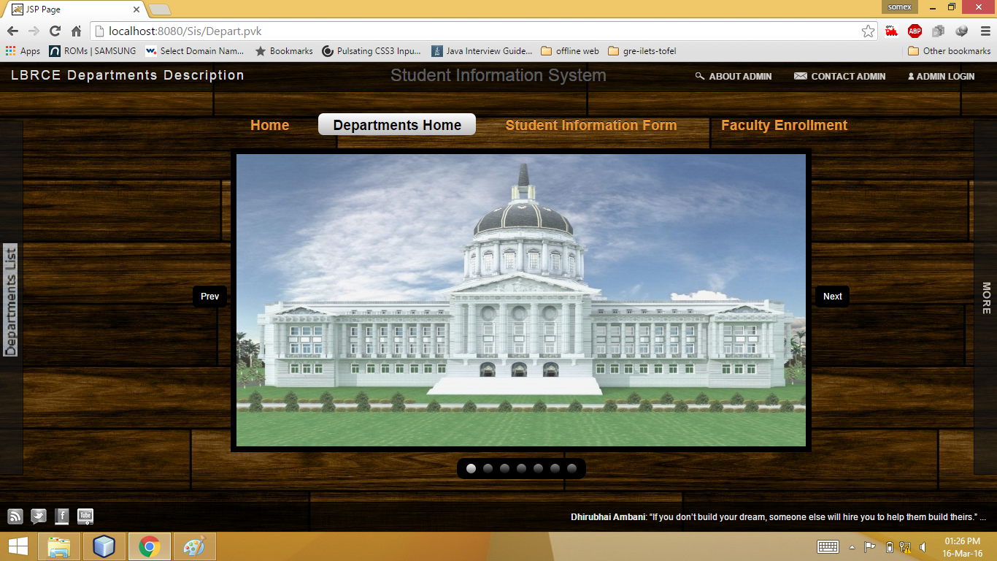

**FIG 6.2**

**Admin login**

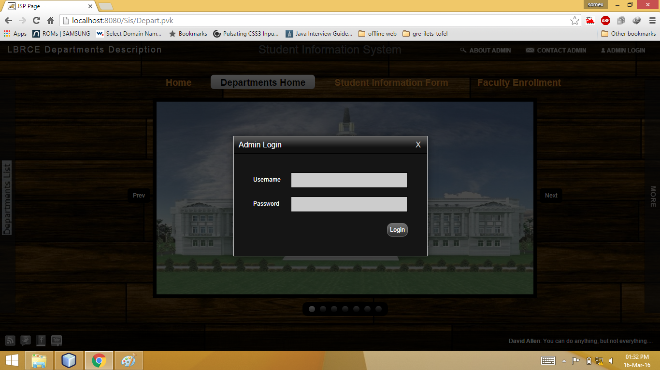

**FIG 6.3**

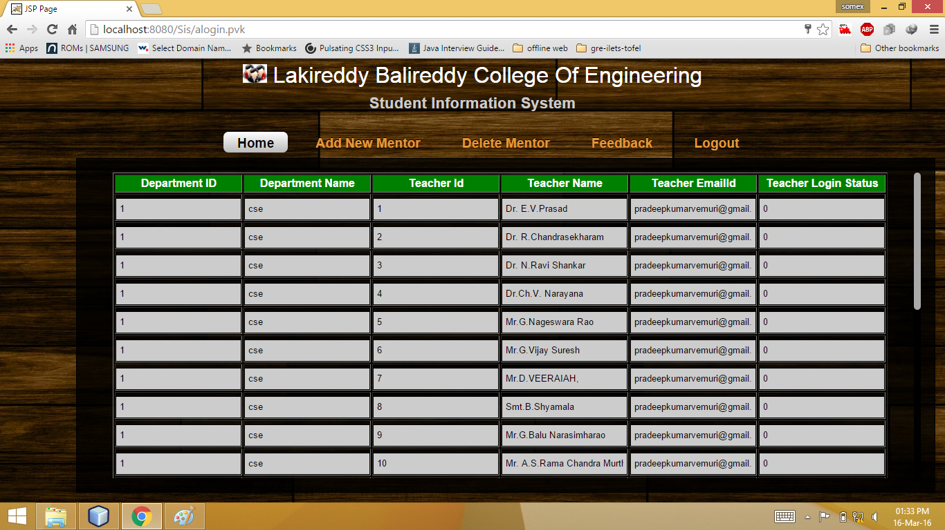

**FIG 6.4**

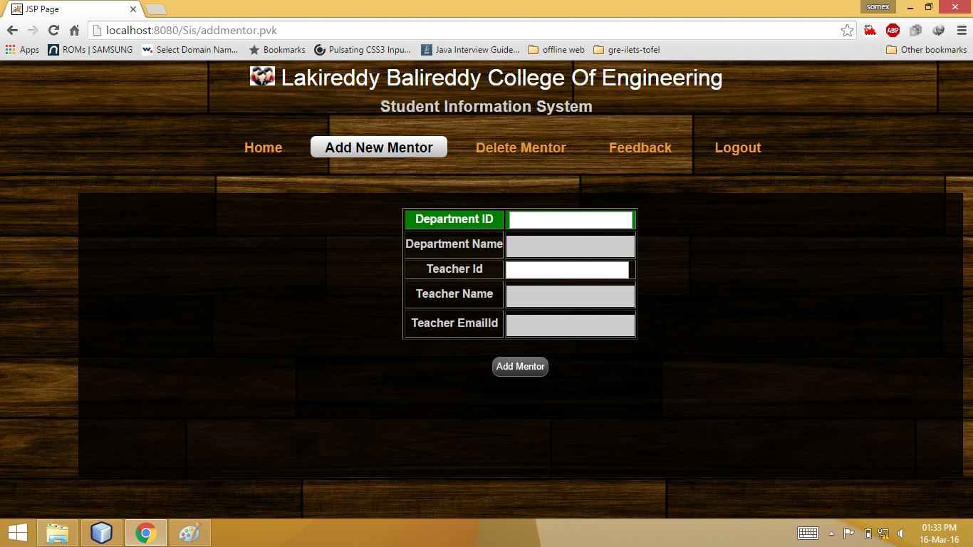

**FIG 6.5**

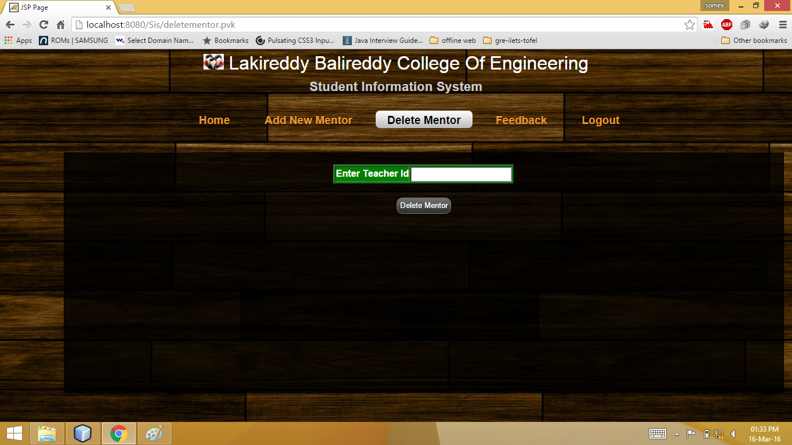

**FIG 6.6**

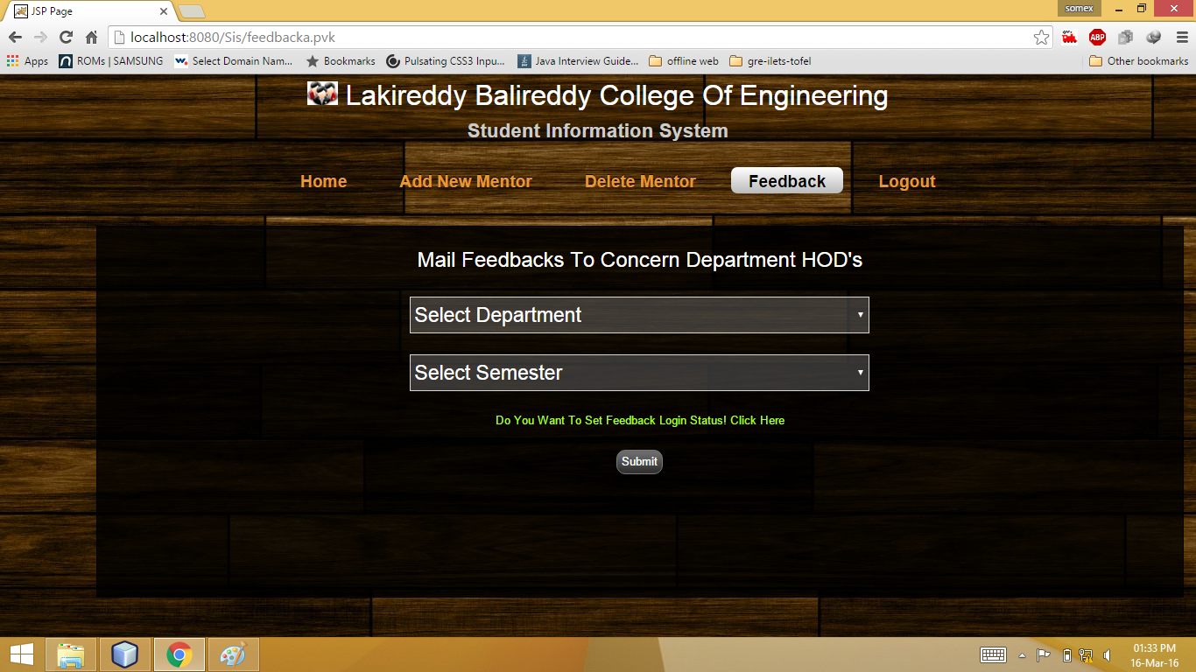

**FIG 6.7**

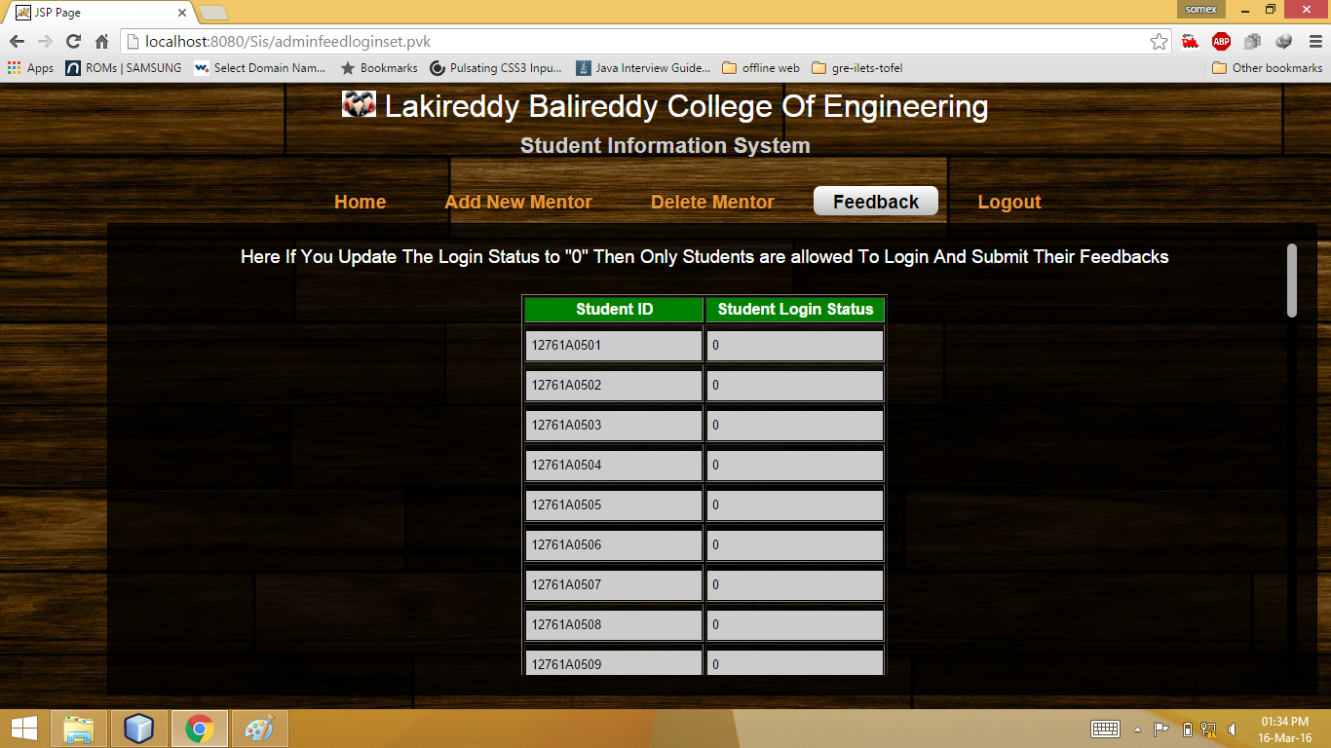

**Fig 6.8**

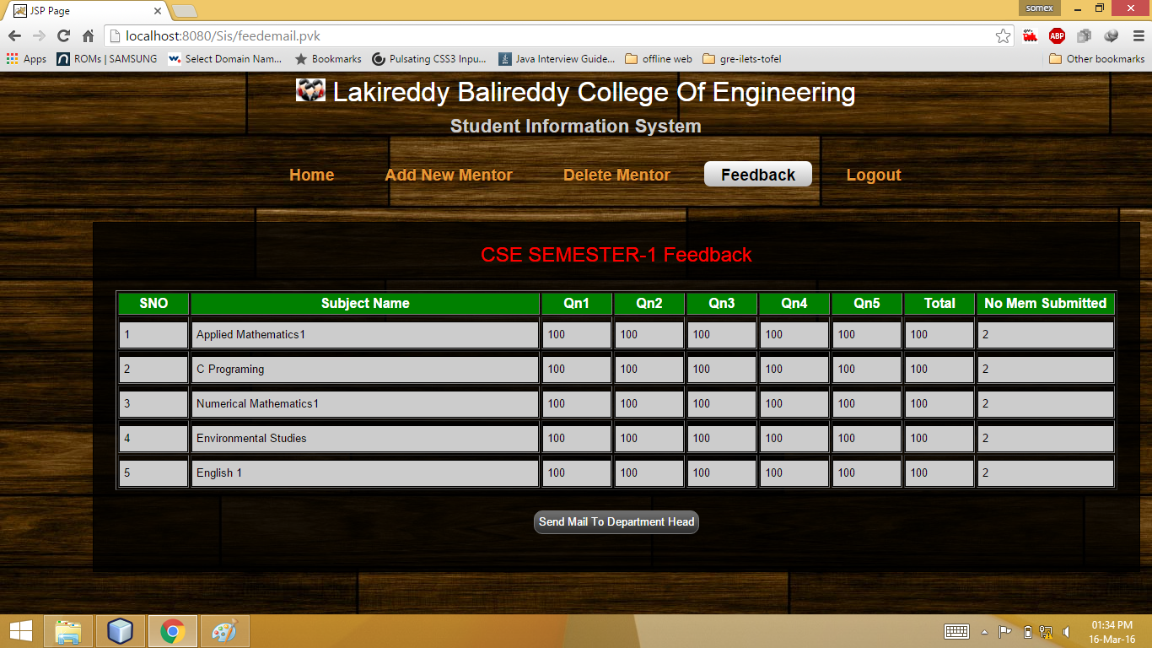

**Fig 6.9**

**Examination cell login**

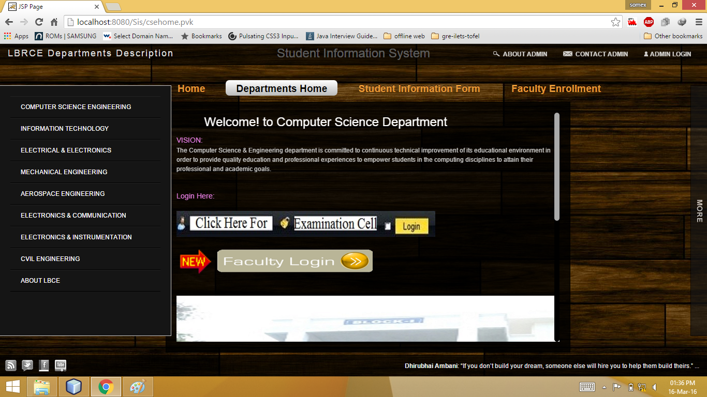

**Fig 6.10**

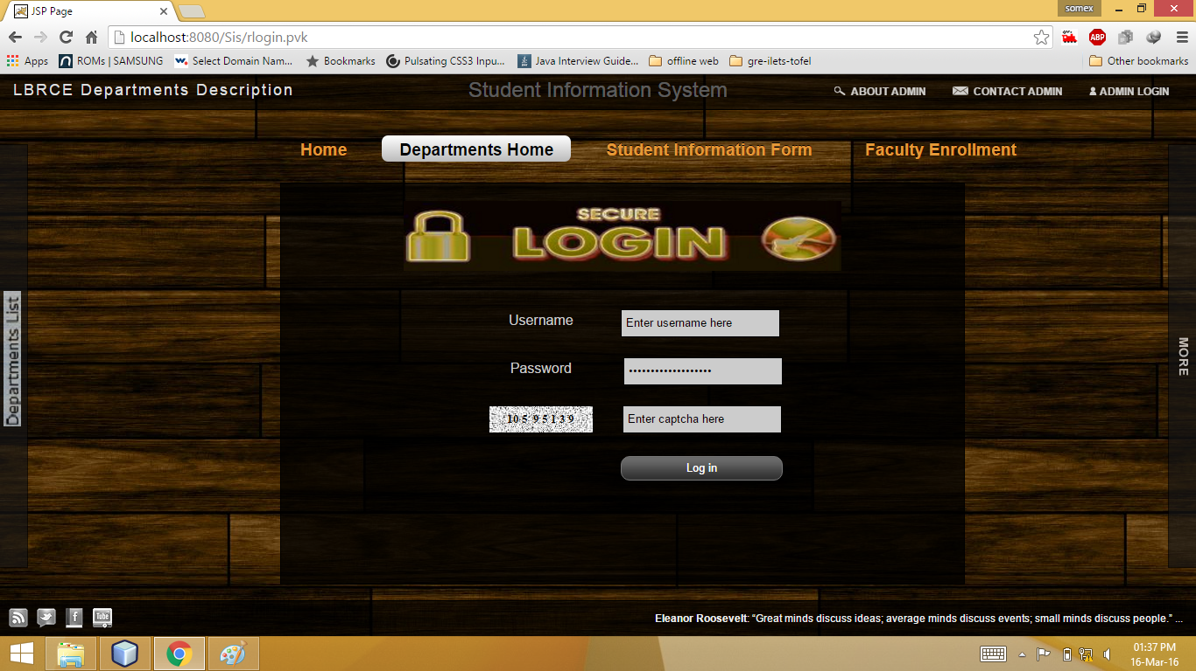

**Fig 6.11**

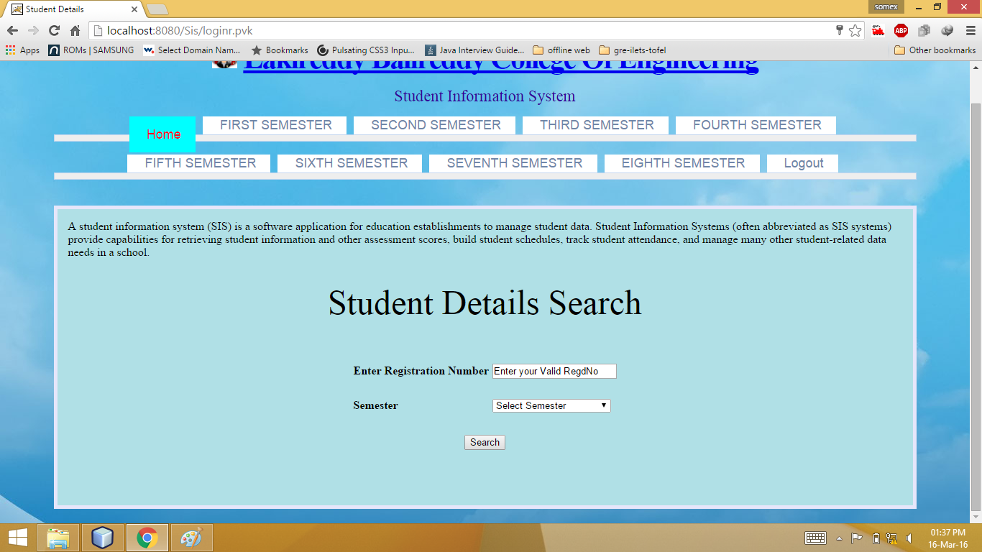

**Fig 6.12**

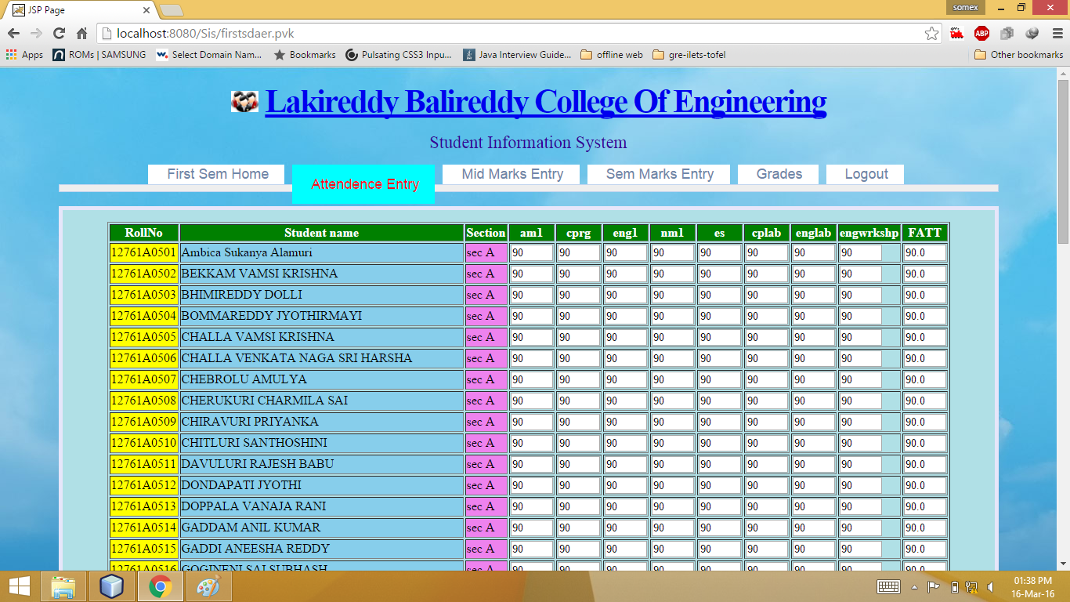

**Fig 6.13**

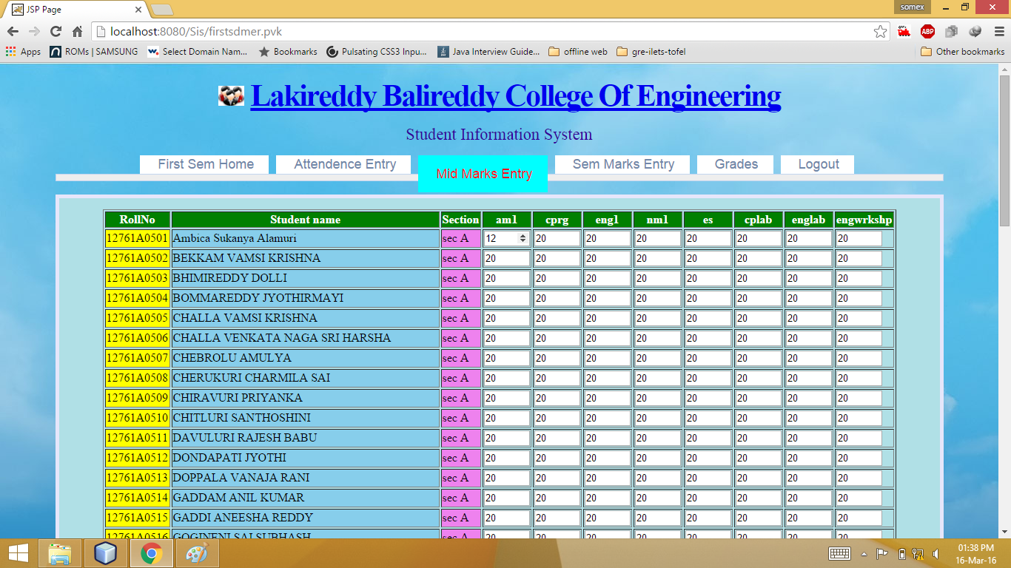

**Fig 6.14**

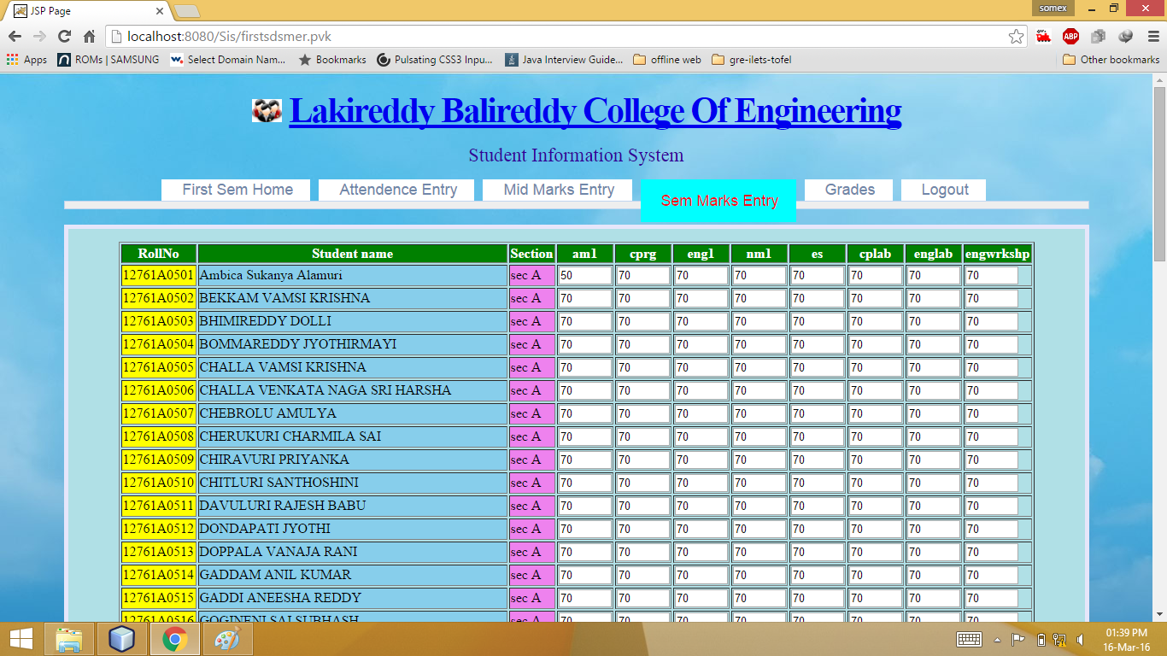

**Fig 6.15**

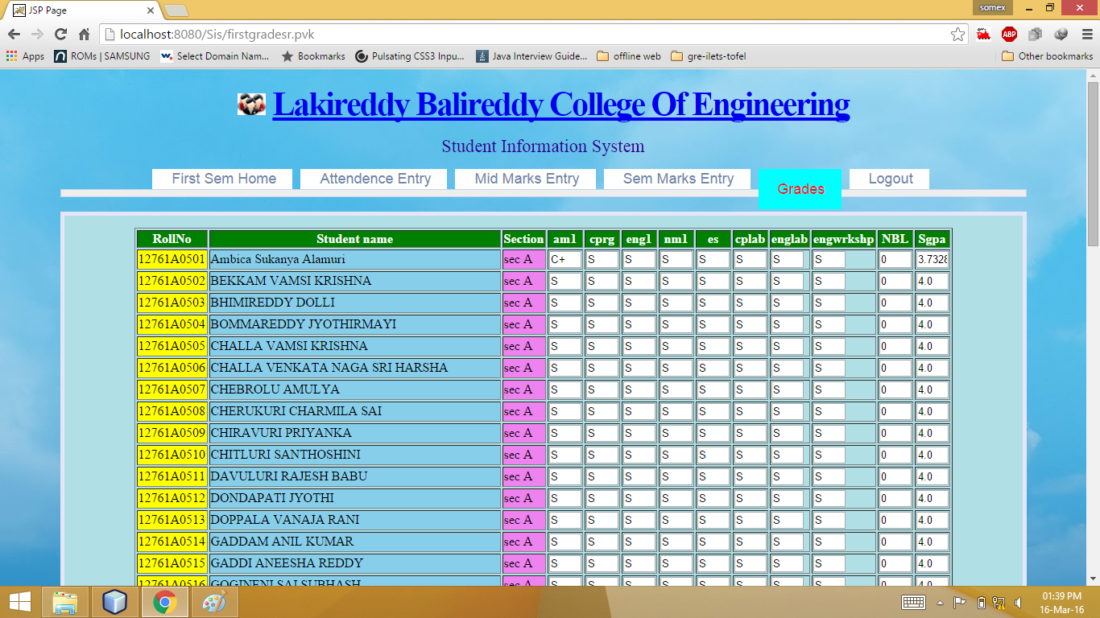

**Fig 6.16**

**Faculty login**

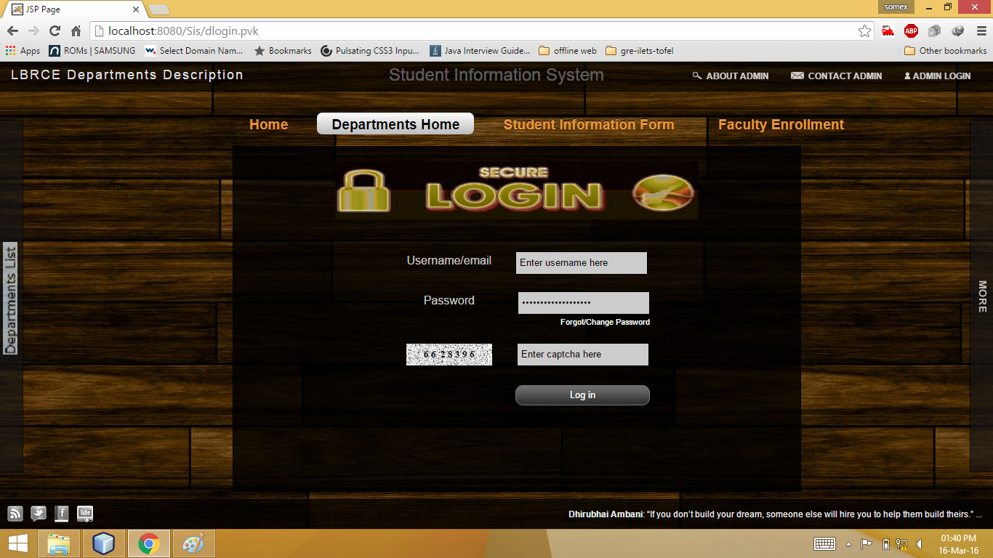

**Fig 6.17**

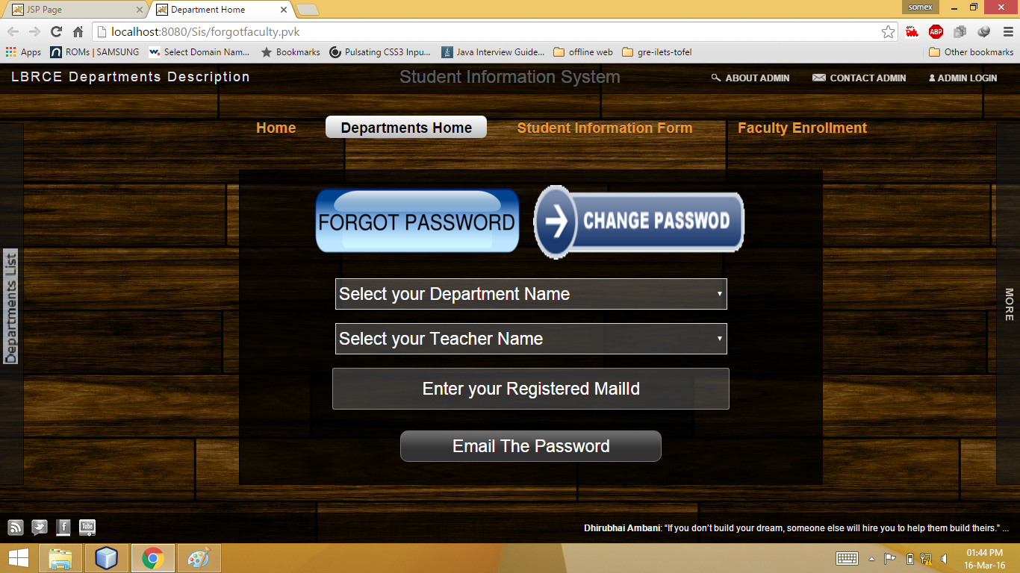

**Fig 6.18**

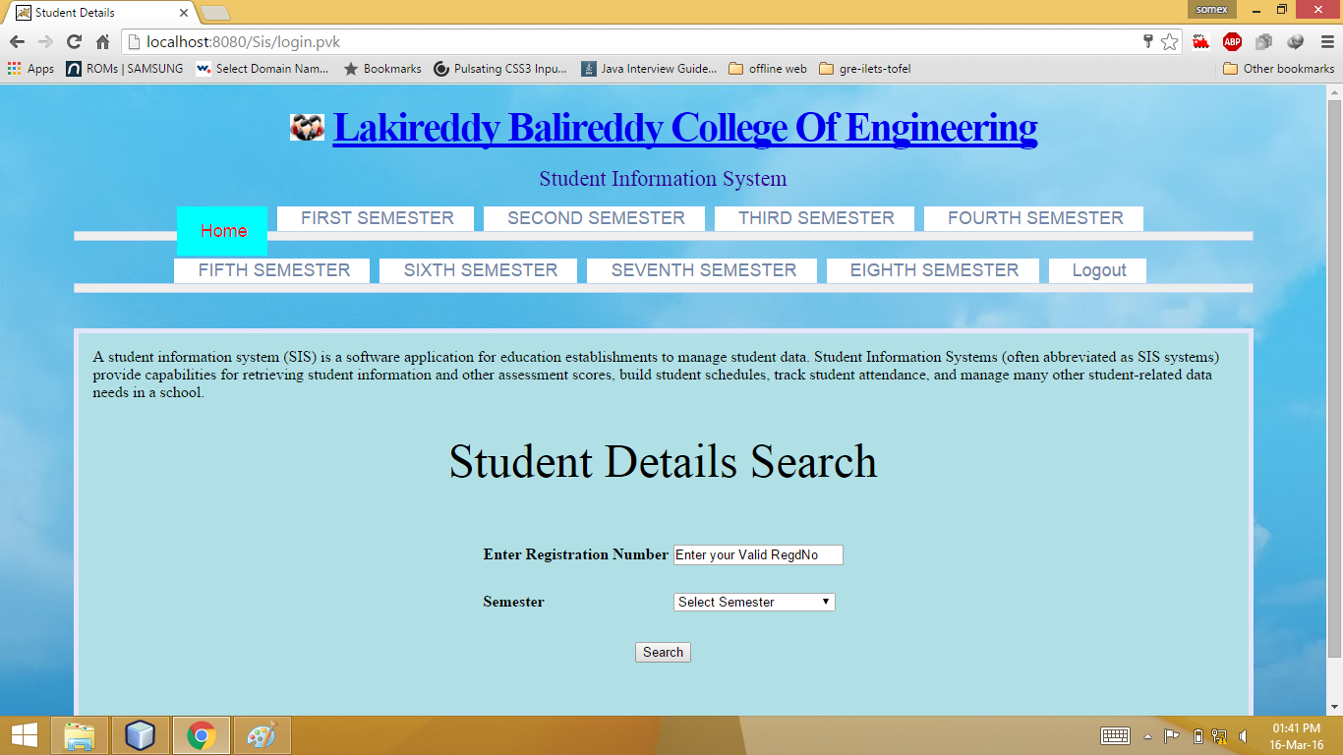

**Fig 6.19**

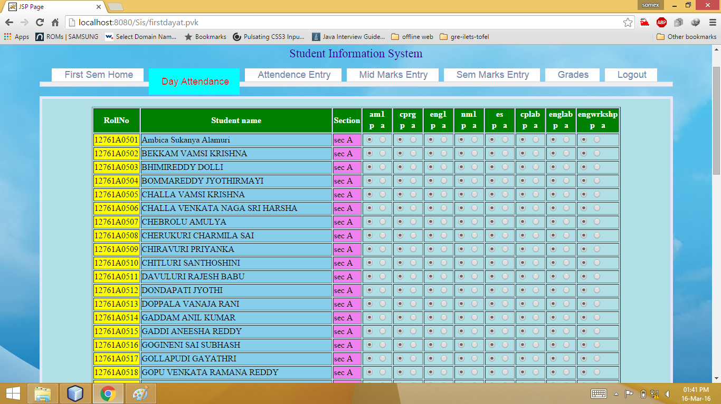

**Fig 6.20**

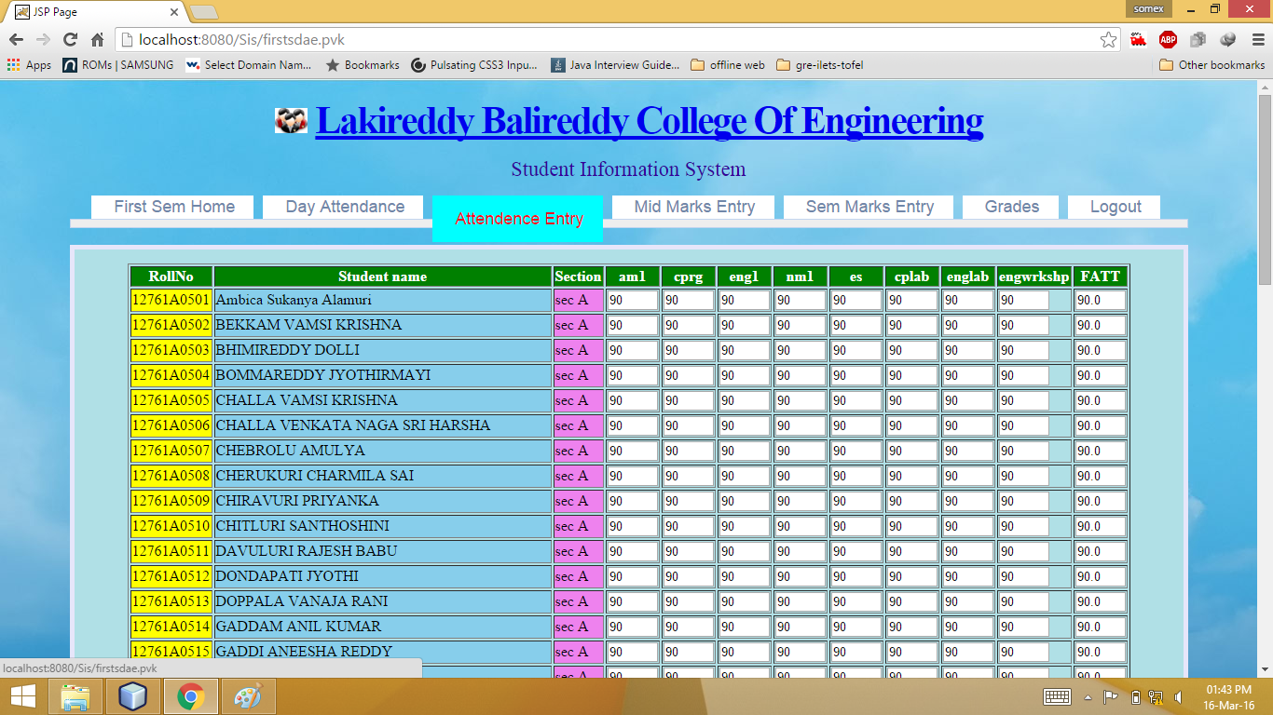

**Fig 6.21**

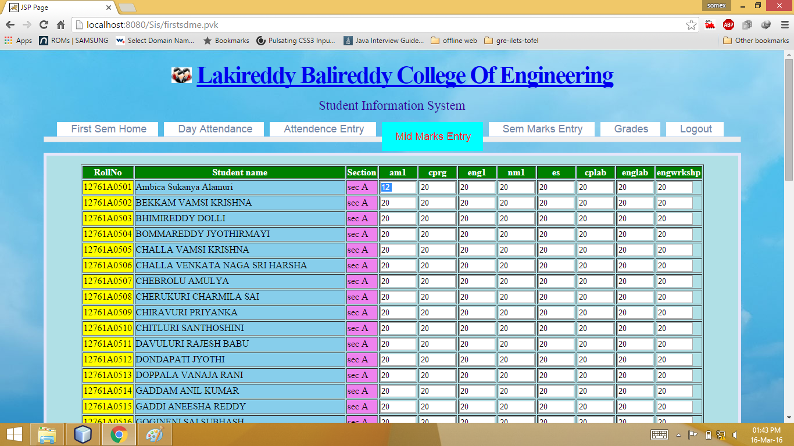

**Fig 6.22**

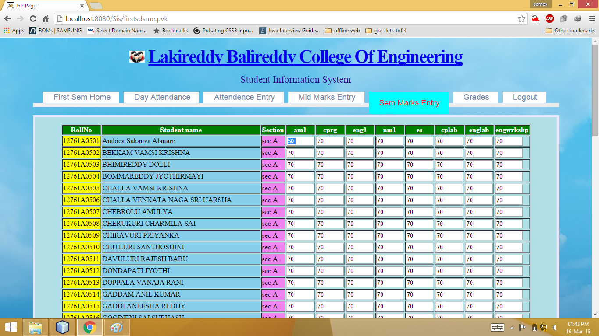

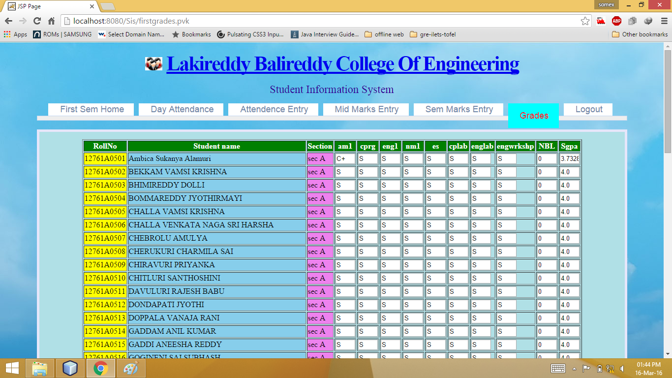

**Student login**

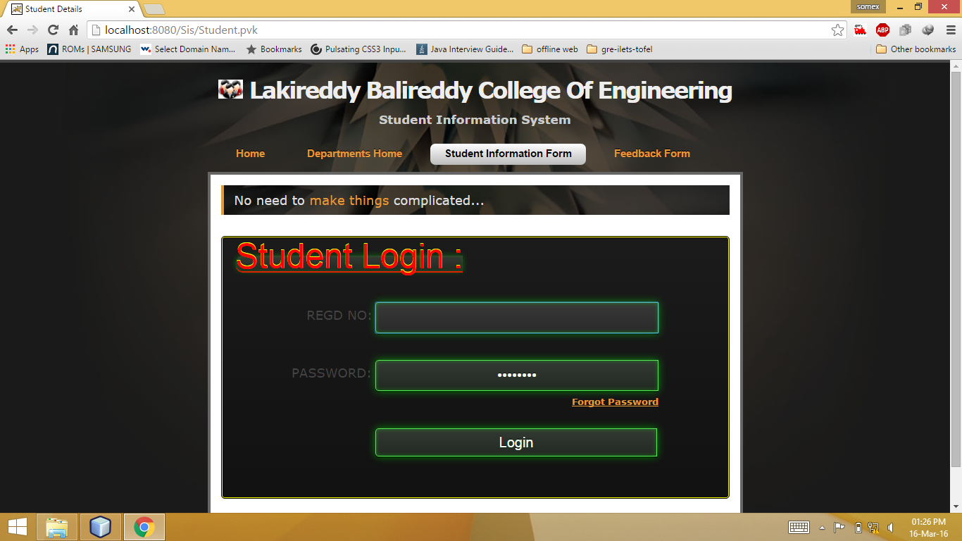

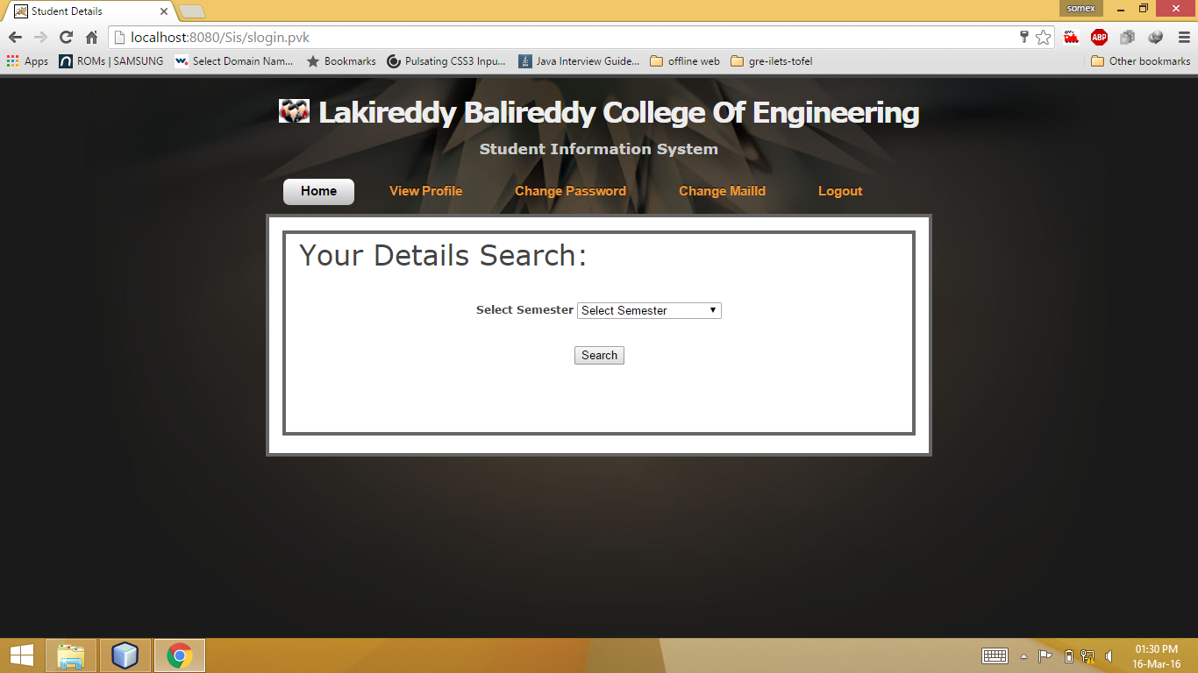

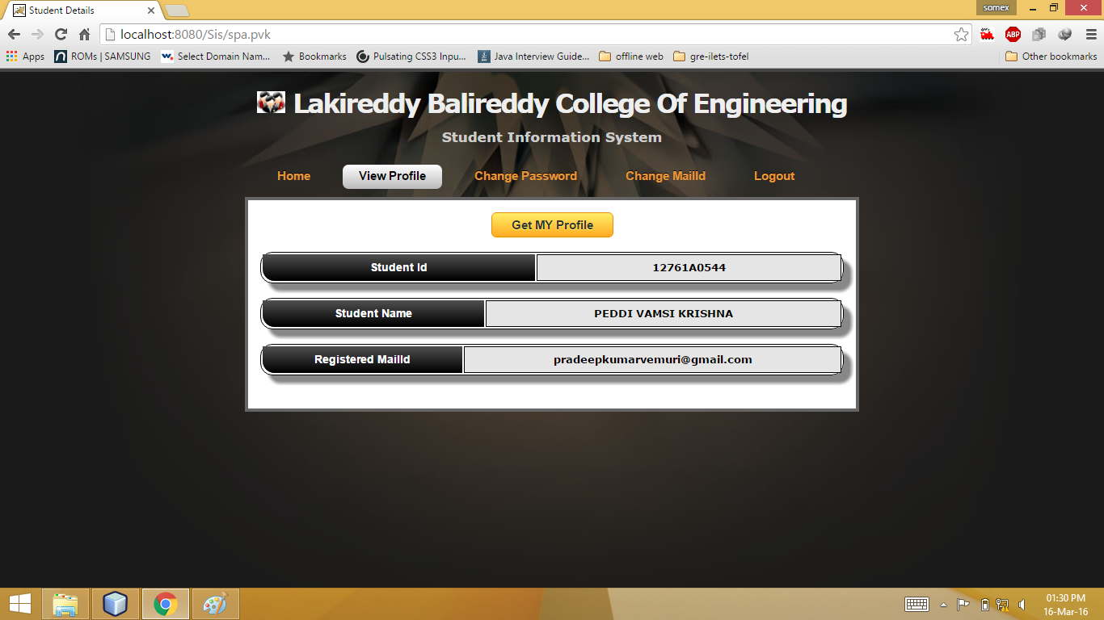

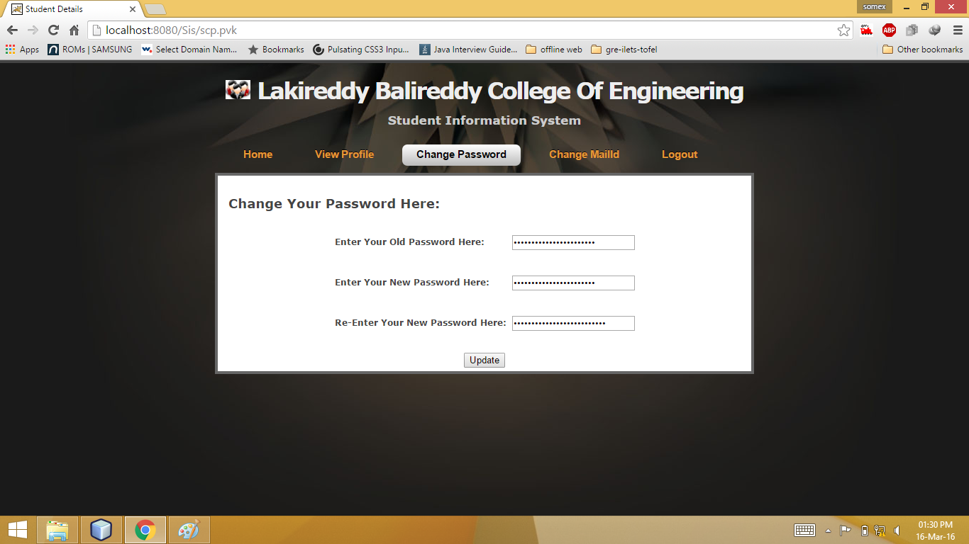

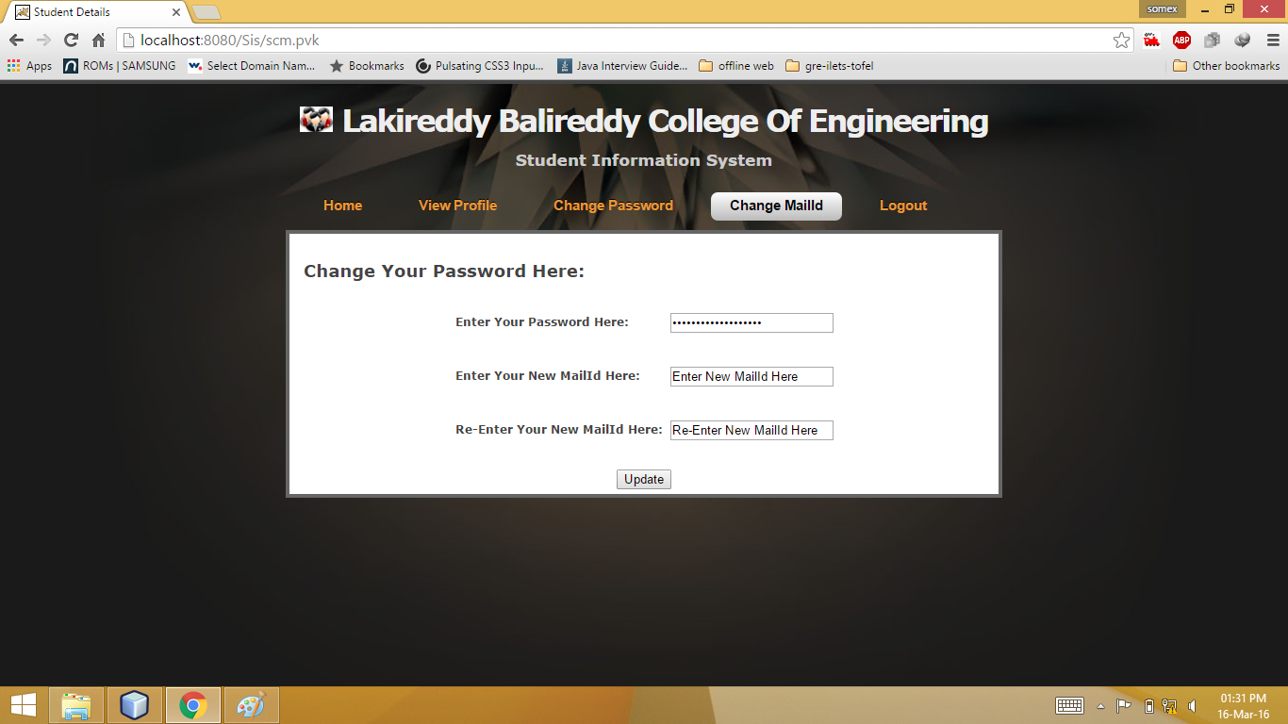

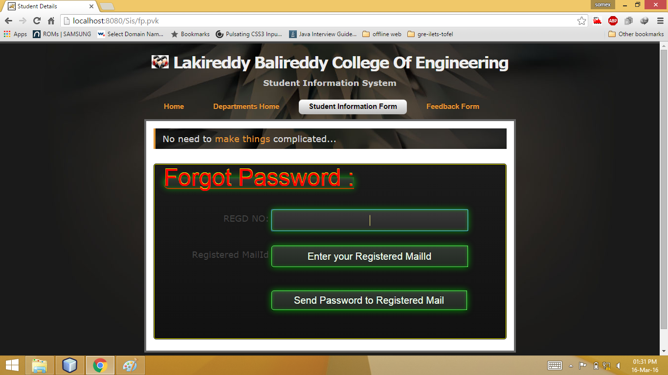

**Feedback login**

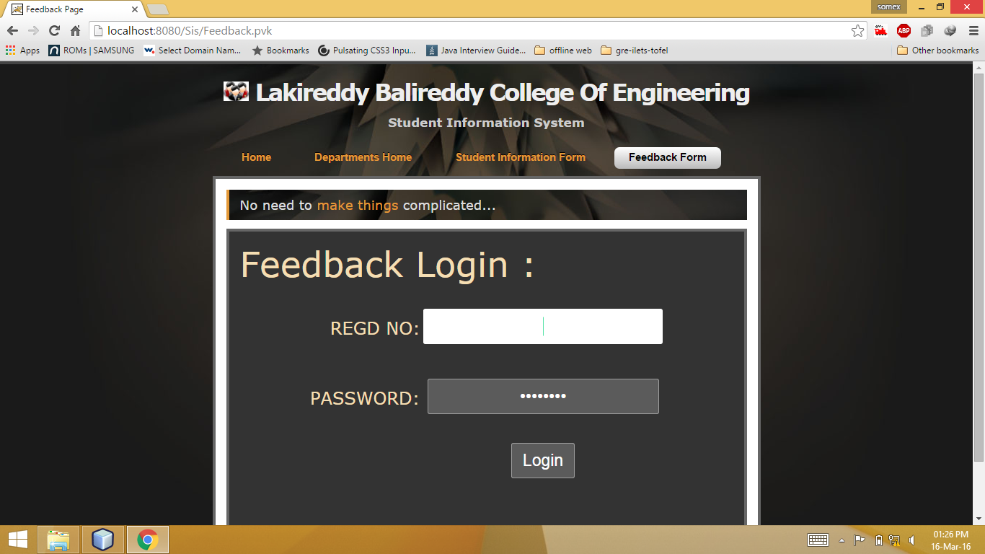

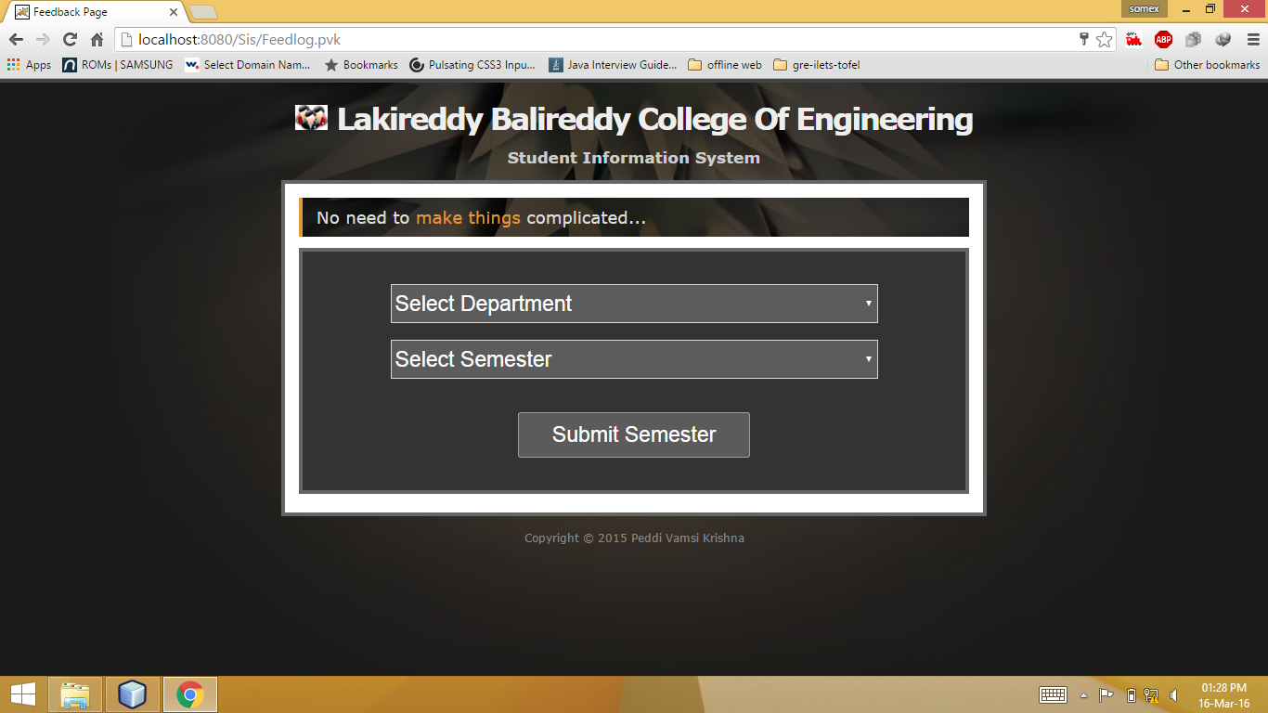

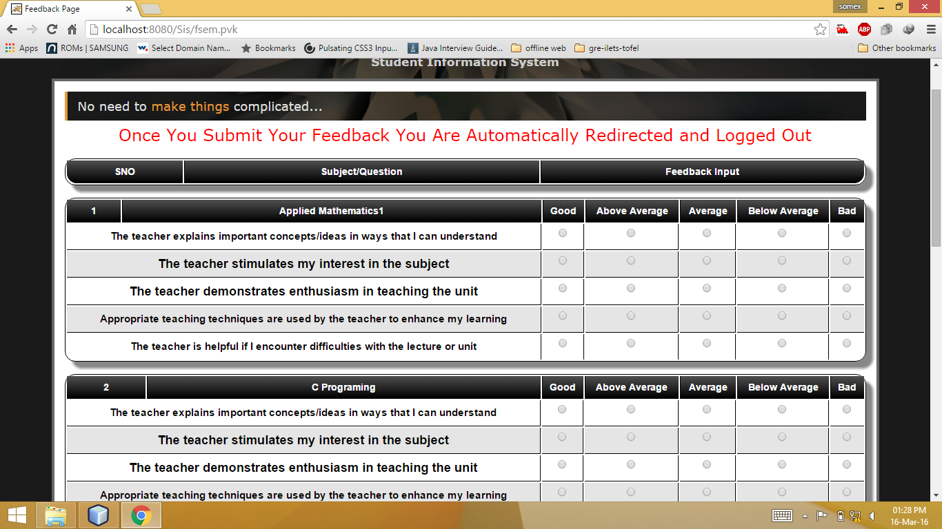

**Chapter - 7**

1. **Conclusion**

If the project that we are working on takes a commercial wave, there can be lot of components that can be integrated so that the system becomes more significant in usage. If the project gets commercial approval, then we can even integrate the modules of online fee payment system by integrating payment gateways to the ongoing system. Extra security features can also be embedded into the ongoing system. We can directly integrate it to the sms gateway server so that the information reaches to the students instantly upon the access of the website.

This project would actually reduce redundancy of data. Data is one of the most costly components in the field of computer technology. At this time we need to reduce data redundancy and should be able to provide better services to the clients.

Whenever any student project takes commercial look, then the real use of the project would come out and reach the end user totally.

**8. BIBLIOGRAPHY AND REFERENCES**

* http://www.javajsf.blogpost.com
* An Introduction to JAVA SERVER FACES(3rd Edition)
* Head First JSF
* JAVA 2 Complete Reference(6th Edition)
* Oracle-Complete References
* http://blogs.sun.com/appservwriters/entry/review_request_glassfish_v2_documentatio
* http://glassfish.java.net/javaee5/docs/DocsIndex.html
* <http://netbeans.org/kb/docs/ide/java-db.html>
* <http://www.roseindia.net/jsf/jsfcomponents.shtml>
* http://www.techienuggets.com/Detail?tx=9700